Unit: Enviromental Problems.
Vocabulary:
Greenhouse Effect- Efecto invernadero. Air Pollution-Contaminación del Aire.
Cans- Latas Rain forest- Bosque de Pluvisilva.
Oil-Petróleo Sun protection-Crema solar.
Endangered- Amenazado. Rise-Incremento.
Dumping site-Vertedero Carbon Dioxide- Dióxido de Carbono.

1. What do you think?
Decide the following ideas:
a) will happen in the next 50 years? Puede ocurrir en los próximos 50 años.
b) could happen? Puede ocurrir.
c) won’t happen? No ocurrirá.
Mark the sentences a, b or c.
1) Cars will be electric. .
2) Alternative energy will be more important than oil.
3) You will recycle all your bags, cans and paper.
4) The rainforests will disappear.
5) You don´t need to use sun protection.
6) The level of the sea will increase.
7) People will destroy the earth.
2. Link with arrows:
Acid Layer Destruction
Greenhouse Pollution
Ozone Rain
Endangered Effect.
Air Species.

3. Complete the sentences:
Rainforest, Renewable, Soil, Biosphere, Greenhouse Effect, Endangered, Animals, Layer.
a) The _______ is the part of the earth's atmosphere and surface in which ______ and plants can live.
b) The use of ________ sources could stop the destruction of the_______.
c) The sea turtle is an ________ species.
d) The ___________ is the rise in temperature caused by gases in the atmosphere.
e) The ozone ________ screens out the sun's harmful ultraviolet radiation.
f) _______ is the top layer of the earth in which trees, plant etc. grow.
4. Link the concepts with the images:
Sea pollution, Air pollution, Dumping Site, Greenhouse Effect, Endangered Species, Acid Rain.Effects.
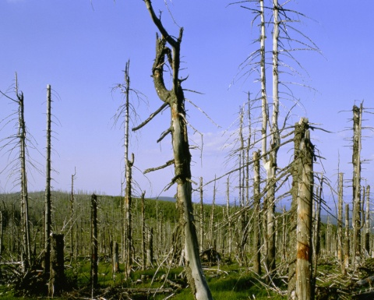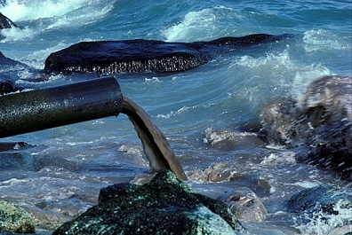
_________________________ ________________________
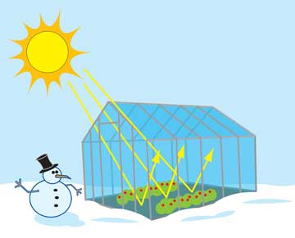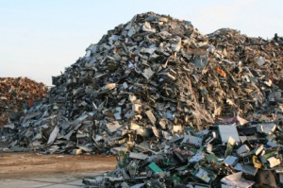
__________________________ _________________________
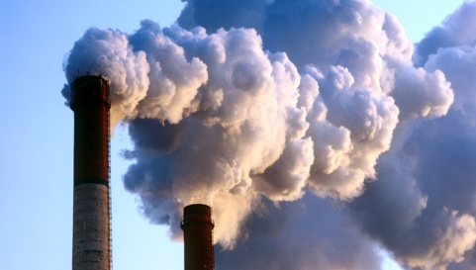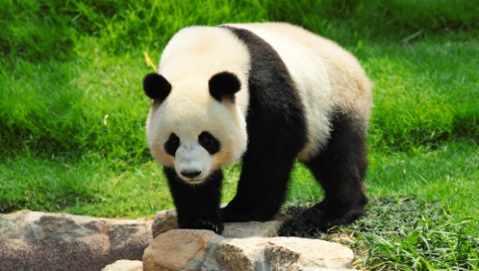
__________________________ __________________________

5. Listen and answer:
https://www.youtube.com/watch?v=ScX29WBJI3w
a) According to the speaker, greenhouse gases are produced by….
- Heat from the sun.
- The actions of people.
- The sun´s rays, and also the actions of people.
- The video doesn´t say.
b) Wich of these things is a greenhouse gas?
- Carbon monoxide.
- Carbon dioxide.
- Oxygen.
- The vido doesn´ say.
c) Which of these ways to generate power provides a clean source of energy?
- Gas.
- Oil.
- Wind power.
- They are all clean sources of energy.
d) Which of these things can help reduce levels of carbon dioxide?
- Driving to work.
- Heating with coal instead of gas.
- Using of public transport.
- Leaving your TV on standby, rather than swichting it off.

