PROYECT
THE ALMOND TREE
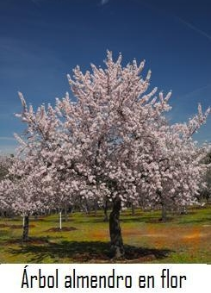

VOCABULARY
Almond tree: árbol del almendro
Almond: almendra
Flowers: flores
Climate: clima
Dirty: seco
Trunk: tronco
Branch: rama
Spring: primavera
Summer: verano

