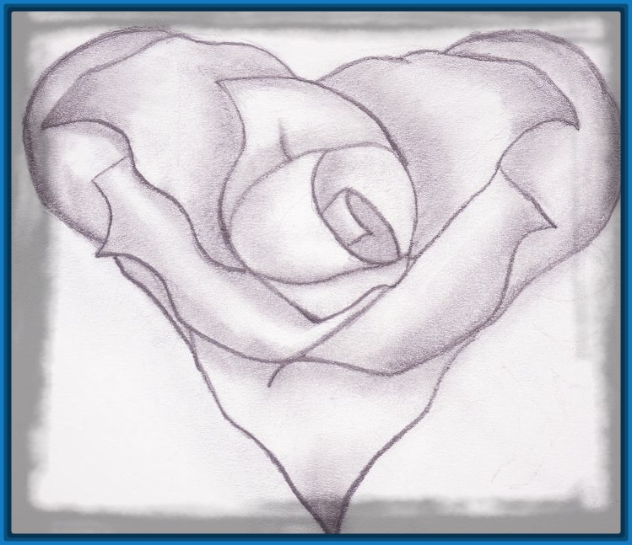
Your Beliefs
Don’t make You
a better Person ,
Your
Behaviour
Does

