THE UNIVERSE

- Vocabulary bank
(The Solar System + the Universe)

- Reading (seven exoplanets discovered) + VIDEO (Trappist 1)

- Reading (the search for aliens) + VIDEO (Prof Brian Cox – Are aliens trying to contact us?)

- Discussion

The Solar System
Saturn /ˈsætɜːn/  Mars /mɑːz/  Neptune /ˈnɛptjuːn/  Uranus /jʊˈreɪnəs/ | Earth /ɜːθ/  Jupiter /ˈdʒuːpɪtə/  Mercury /ˈmɜːkjʊrɪ/  Venus /ˈviːnəs/
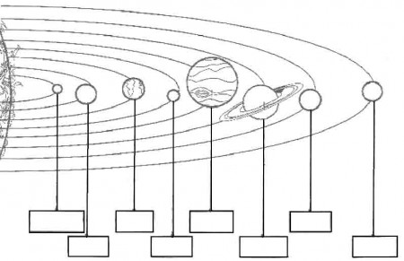

There are eight planets in our solar system and they all orbit round the Sun. The closest planet to the Sun is Mercury and then comes Venus. Planet Earth is the third closest planet to the sun.
Mars is the fourth planet from the sun. It is a small red planet, named after the Roman god of war. Jupiter is the largest planet in our solar system and it has at least 67 moons or satellites.
The next planet is Saturn which is a gas giant and has thin rings around it. Uranus and Neptune are the next two planets after Saturn. Pluto used to be considered a planet, but now it is called a dwarf planet because of its small size.
The Solar System also contains smaller objects such as dwarf planets, satellites or the asteroid belt which lies between the orbits of Mars and Jupiter.

The Universe
Match these words to their definitions

- Constellation __
- Astronaut __
- UFO __
- Spacecraft __
- Telescope __
- Comet __
- Asteroid __
- Orbit __
- Astronomy __
- Alien __
__________________________
- The scientific study of the stars and planets.
- Someone who travels and works in a spacecraft.
- A creature from another world.
- One of the many small planets that move around the Sun, especially between Mars and Jupiter.
- A group of stars that forms a particular pattern, e.g. the constellation of Orion, the Big Dipper.
- To travel in a curved path around a much larger object such as the Sun.
- Unidentified Flying Object
- An object in space like a bright ball with a long tail that moves around the sun: Halley’s comet.
- A piece of equipment shaped like a tube, used to make distant objects look larger and closer.
- A vehicle that is able to travel in space.
ANSWER KEY: THE SOLAR SYSTEM
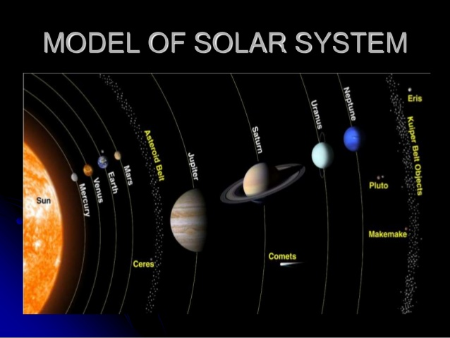
THE UNIVERSE

- E
- B
- G
- J
- I
- H
- D
- F
- A
- C

Seven new exoplanets discovered
NASA's Spitzer Space Telescope has revealed the first known system of seven Earth-size planets around a single star. Three of these planets are firmly located in the habitable zone, the area around the parent star where a rocky planet is most likely to have liquid water.
The discovery sets a new record for greatest number of habitable-zone planets found around a single star outside our solar system. All of these seven planets could have liquid water – key to life as we know it – under the right atmospheric conditions, but the chances are highest with the three in the habitable zone.
“This discovery could be a significant piece in the puzzle of finding habitable environments, places that are conducive to life,” said Thomas Zurbuchen, associate administrator of the agency’s Science Mission Directorate in Washington. “Answering the question ‘are we alone’ is a top science priority and finding so many planets like these for the first time in the habitable zone is a remarkable step forward toward that goal.”
At about 40 light-years (235 trillion miles) from Earth, the system of planets is relatively close to us, in the constellation Aquarius. Because they are located outside of our solar system, these planets are scientifically known as exoplanets.
This exoplanet system is called TRAPPIST-1, named for The Transiting Planets and Planetesimals Small Telescope (TRAPPIST) in Chile. In May 2016, researchers using TRAPPIST announced they had discovered three planets in the system. Assisted by several ground-based telescopes, including the European Southern Observatory's Very Large Telescope, Spitzer confirmed the existence of two of these planets and discovered five additional ones, increasing the number of known planets in the system to seven.
The new results were published Wednesday in the journal Nature, and announced at a news briefing at NASA Headquarters in Washington.

In contrast to our sun, the TRAPPIST-1 star – classified as an ultra-cool dwarf – is so cool that liquid water could survive on planets orbiting very close to it, closer than is possible on planets in our solar system. All seven of the TRAPPIST-1 planetary orbits are closer to their host star than Mercury is to our sun. The planets also are very close to each other. If a person was standing on one of the planet’s surface, they could gaze up and potentially see geological features or clouds of neighboring worlds, which would sometimes appear larger than the moon in Earth's sky.
The planets may also be tidally locked to their star, which means the same side of the planet is always facing the star, therefore each side is either perpetual day or night. This could mean they have weather patterns totally unlike those on Earth, such as strong winds blowing from the day side to the night side, and extreme temperature changes.
Following up on the Spitzer discovery, NASA's Hubble Space Telescope has initiated the screening of four of the planets, including the three inside the habitable zone. These observations aim at assessing the presence of puffy, hydrogen-dominated atmospheres, typical for gaseous worlds like Neptune, around these planets.
Spitzer, Hubble, and Kepler will help astronomers plan for follow-up studies using NASA's upcoming James Webb Space Telescope, launching in 2018. With much greater sensitivity, Webb will be able to detect the chemical fingerprints of water, methane, oxygen, ozone, and other components of a planet's atmosphere. Webb also will analyze planets' temperatures and surface pressures – key factors in assessing their habitability.

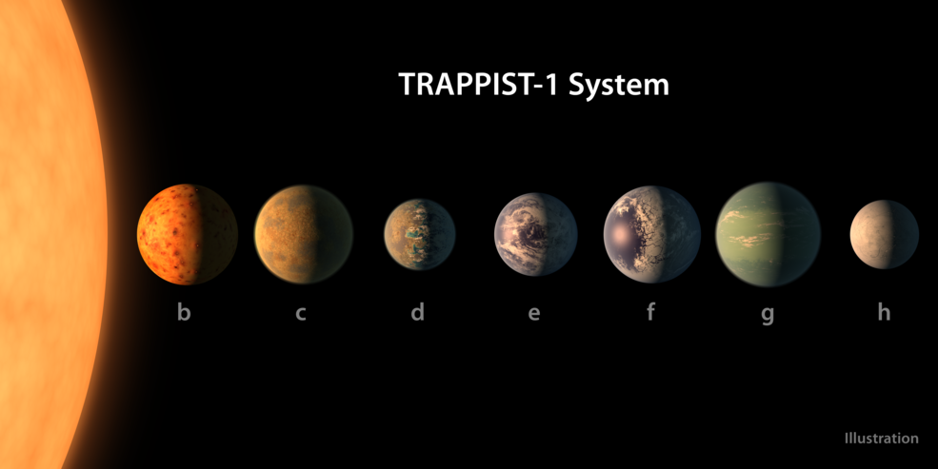
VIDEO LINK: https://www.youtube.com/watch?v=bnKFaAS30X8

Brian Cox Physicist and presenter
The search for aliens
Are we the only island of life in the vastness of space, or is our Galaxy teeming with other civilisations?
We've long been intrigued by the idea that we are not alone. The search for extra-terrestrial intelligence (SETI) - was born from this curiosity - the use of sophisticated scientific methods to try to detect a signal coming from life elsewhere in the Galaxy.
In the 1960s, radio astronomy was put to work in the search. Radio telescopes surveyed the sky, searching for something that might come from an alien civilisation. For years they heard nothing except the background hum of space. Then one day in 1977, a radio telescope in the US received a signal...

A signal from space
The Wow! signal fitted the profile of an alien transmission. Other explanations have been ruled out. Transmitters on Earth can’t use the same frequency, and the signal was too narrow to come from natural sources

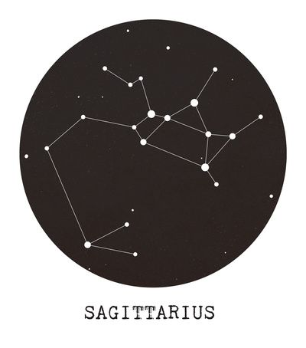
Never to be heard again
The Wow! signal was detected by the Big Ear radio telescope in Ohio. Scientists immediately searched for a repeat of the Wow! signal. They scanned the sky in the direction of the constellation Sagittarius, where the signal had come from. And as technology improved, more sensitive telescopes were put on the case, along with software that was designed to find signals among the background noise.
But despite several decades of searching, the signal has never been seen again. It remains a mystery.
So how likely are we to ever find intelligent life, somewhere in our Galaxy?
Video Link: https://www.youtube.com/watch?v=9sQ_jlIPAbg
Discussion: are we alone?
- Have you (or anyone you know) ever seen a UFO?

- Do you believe in life on other planets? Do you think there might be extra-terrestrial intelligence? Why (not)?

- Will human beings ever colonise other planets? Why (not)?

