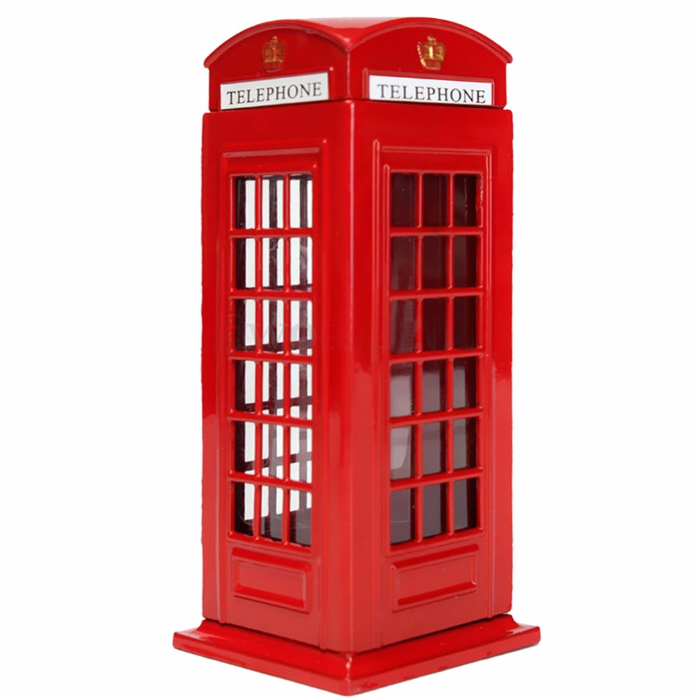


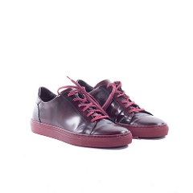
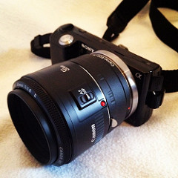


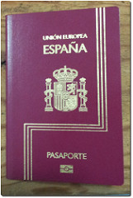

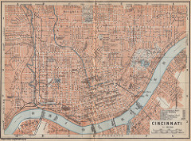
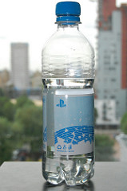


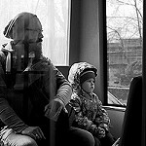


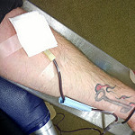


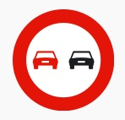
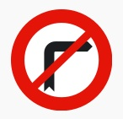
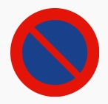


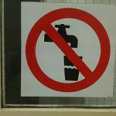
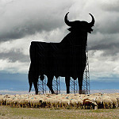
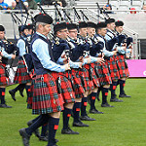


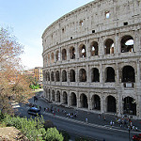

Tema 3: I have to take my passport

Rellenar huecos
Si has entendido el texto intenta completar la tabla con el orden en el que aparecen los diferentes ítems.
(1): | (2): | (3):
(4): | (5): | (6):
(7): | (8): | (9):

Completa las frases con HAVE TO o HAS TO:
Principio del formulario
1. They write a test.
2. She clean her desk.
3. Ken and learn English words.
4. Andy help his brother.
5. We do our homework.
6. He write with a pencil.
7. I feed the hamster.
8. You): take photos.
Final del formulario
Final del formulario

Completa las frases con la forma negativa de HAVE TO (doesn't have to o don't have to):
Principio del formulario
1. He doesn't have to work in the evening.
2. We don't have to go shopping.
3. My friends doesn't have to get up early.
4. Olga doesn't have to read the instructions of her camera.
5. You don't have to do the project.
6. I don't have to play the guitar.
7. They don't have to carry the buckets.
8. She doesn't have to wash my T-shirt.

Ya has hecho ejercicios en afirmativa y en negativa. Ahora vamos a trabajar un poco la interrogativa. Recuerda que estamos viendo HAVE TO en presente y que se construye como el Presente Simple.
Vuelve a leer las cinco primeras frases del ejercicio anterior. ¿Serías capaz de transformarlas a interrogativa?
1. Does he have to work in the evenings?
2. Do we/you have to go shopping?
3. Do my/your friends have to get up early?
4. Does Olga have to read the instructions of her camera?
5. Do you have to do the project?

¿Qué es obligatorio?
Olga lleva bastante tiempo en Inglaterra y ahora va a Irlanda del Norte. Ya conoce muchas normas básicas para no cometer ninguna infracción. Pero ¿y tú? ¿Conoces normas básicas británicas?
En este apartado vas a conocer algunas normas de la sociedad británica en lo que a la edad legal se refiere. Además vas a aprender cómo se expresa la obligación y la prohibición. Así mismo, volveremos a practicar sobre la expresión de permiso CAN.
A continuación te dejamos algunas normas sobre la edad:
- You can drive a very large vehicle at the age of 21. (Puedes conducir un vehículo pesado con 21 años)
- When you are 10, you are legally responsible for any crimes you commit. (Cuando cumples 10 años, eres legalmente responsable de los crímenes que cometas)
- People have to be 21 if they want to be elected for the European Parliament. (La gente tiene que ser mayor de 21 años si quieren ser elegibles para el Parlamento Europeo)
- If you want to leave school, you have to wait until you are 16. (Si quieres abandonar el colegio, tienes que esperar hasta los 16 años)
- If you are 16, you have to ask for your parents' permission to have your own passport. (Si tienes 16, tienes que pedir permiso a tus padres para tener tu propio pasaporte)
- You can't buy lottery tickets and collect the prize money if you are under 16. (No puedes comprar cupones de lotería ni recoger premios en metálico si tienes menos de 16 años)
- You can work for a certain number of hours a week at the age of 13. (Puedes trabajar un cierto número de horas a la semana a partir de los 13 años)
- You have to pay a child's ticket on most buses when you are 5. (Tienes que pagar por el ticket del autobús si tienes 5 años)
- If you need to borrow money from a bank, you have to be 18. (Si necesitas dinero prestado por el banco, tienes que tener 18 años)
- You have to be 17 in order to give blood. (Tienes que tener 17 años para donar sangre)

Relaciona estas imágenes con las normas sobre edad que existen en Gran Bretaña.

A |  | B |  | C |  | D

E |  |  | F |  |  |  | G |  |  | H
J |  |  |  |  | K
Final del formulario

Solución
1G 2D 3H 4B 5J 6E 7 A 8C 9K 10 F

Realiza el siguiente ejercicio. Tan sólo tienes que rellenar el hueco con la forma correcta de la expresión de obligación HAVE TO. Presta especial atención al tiempo de la oración (presente o pasado) y a su sujeto.

If you want to lose weight, you (1): (2): eat more vegetables and fruit. You (3): (4): (5): come to John's birthday party if you don't want to.
I (6): (7): do military service when I was younger. It was obligatory.
We (8): (9): (10): wear a uniform at school. We could wear the clothes we wanted.
You (11): (12): bring your passport. Otherwise* they won't let you on the plane. (*Si no)
Peter (13): (14): (15): get up early every day because he is retired*. (*jubilado)
Your parents (16): (17): (18): come if they don't feel like it.
Sally (19): (20): do her homework before she goes out to play.
You (21): wear a seatbelt (cinturón de seguridad) in the car.
Last week we (22): (23): fly to London because there was an important meeting there.

Elige entre MUST o HAVE TO:
Principio del formulario
1. A WORKMATE: John, you must finish your project today.
JOHN: I have to finish my project today.
2. SON: have to clean my room.
FATHER: must clean your room or you won't go out.
3. A BANK BOARD: You must wait here.
CLIENT: I have to wait here.

Mira las siguientes imágenes e indica qué está prohibido. Como son prohibiciones generales, utiliza YOU como sujeto. En el recuadro tienes el vocabulario necesario. Hay más expresiones de las necesarias.
bring pets | drink this water
eat snacks or food | overtake other cars
park your car here | speak loudly
take photographs | turn right

Principio del formulario
overtake other cars
turn right
park your car here
speak loudly
take photographs
drink this water

bring pets: traer mascotas
drink this water: beber este agua
eat snacks or food: comer aperitivos o comida
overtake other cars: adelantar otros coches
park your car here: aparcar aquí
speak loudly: hablar en voz alta
take photographs: tomar fotos
turn right: girar a la derecha
Encuentra los errores en las siguientes frases:
1. She have to cook dinner.
2. They doesn’t have to eat hamburgers.
3. We has to study for our exam.
4. He has not to be disrespectful.
5. They has to boil their vegetables.
6. You have cook to your onions very well.
7. I doesn’t has to work on Sundays, but I has to go to school on Monday.
8. You has to wash the lettuce very well.
SOLUCIÓN:
1. She has to cook dinner.
2. They don't have to eat hamburgers.
3. We have to study for our exam.
4. He doesn't have to be disrespectful.
5. They have to boil their vegetables.
6. You have to cook your onions very well.
7. I don't have to work on Sundays, but I have to go to school on Monday.
8. You have to wash the lettuce very well.

Copia en tu cuaderno las siguientes frases y tradúcelas al inglés. Usa HAVE TO, CAN, MUST o MUSTN'T.
1. Está prohibido fumar en clase. 2. Puedes conducir un coche si tienes 18 años. 3. Él tiene que terminar el proyecto. 4. No se puede andar por el césped. Está prohibido. 5. No tienes que ir mañana al colegio. Es sábado.
SOLUCIÓN:
1. You mustn't smoke in class.
2. You can drive a car if you are 18 years old.
3. He has to finish the project.
4. You mustn't walk on the grass. It is prohibited.
5. You don't have to go to school tomorrow. It's Saturday.

En el folleto que le dieron a Olga se encuentran las distintas partes que hemos expuesto.
Intenta contestar en tu cuaderno las siguientes preguntas:
1. What is the title? 2. And the subtitle? 3. Who is represented in the photograph? 4. Is there any engaging sentence? Which?
SOLUCIÓN:
1. Derry's Spring Carnival.
2. Welcome! Fáilte!
3. St. Patrick.
4. Yes, "Enjoy your green holidays!"

Cuando uno piensa qué hacer en vacaciones siempre pensamos en el lugar donde ir. Y de este lugar siempre guardamos en la mente una imagen que viene a representarlo. Cada uno puede tener su propia imagen pero seguro que muchos coincidimos en la misma.
¿Qué países representan las siguientes imágenes?
I
SOLUCIÓN:
Picture 1 - Spain
Picture 2 - Scotland
Picture 3 - The United States
Picture 4 - Brazil
Picture 5 - Italy

Los cuatro amigos, Claire, Hugh, Alice y Jeff, aún tiene que decidir dónde ir. Claire ha traído un folleto para tener más opciones:
7 nights Mediterranean Cruise - £849
Venice (Italy), Bari (Italy), Katakolon (Greece), Izmir (Turkey), Istanbul (Turkey), Dubrovnik (Croatia), Venice (Italy) Mediterranean! We will guide you on a voyage of discovery of the history of the Mediterranean, exploring the culture of the most ancient civilisations. We take special pride in guiding you through the Mediterranean's
most exquisite and beautiful corners of history, culture and nature. Kids sail free.
Inside Stateroom Board Basis: Full Board
9 days Laguna Beach resort - £1,350
Laguna Beach Resort is the ideal destination. The Maldives is a piece of paradise. 30 minute by fast boat from the airport and the capital and close to many islands, Laguna is the perfect romantic hideaway for couples in their honeymoon looking for romance.
And if you are travelling with family, the crystal-clear lagoons immediately surrounding the white sands of Laguna Beach Resort are shallow enough for children.Enjoy the colourful tropical fish over a magnificent house reef. Laguna’s diving school will help you experience the underwater world.
Maldives
Hotel rating:*****luxe Board basis: All inclusive
Join this amazing tour that offers such great value. London – Rome direct
regular flight. Your first point of arrival in Italy will be Fuiggi, near Rome,
where you will stay for 5 nights as a base for touring Pompeii, Montecassino, Rome, Sorrento and Capri on de luxe coach. Visit the most important museums in Italy.
Hotel rating:*** Board basis: Bed & Breakfast
voyage: viaje pride: orgullo hideaway: escondite crystal-clear lagoons: lagunas de aguas cristalinas shallow: poco profundo value: valor
Lee estas oraciones sobre el folleto y di si son verdaderas o falsas según la información dada en el mismo.
Principio del formulario
1. In all the holiday trips anounced on the brochure, parents have to pay for their children's holidays. 2. If you like knowing different cultures and places, the cruise is your best choice. 3.The Maldives is a good place for people who are just married. 4. Laguna Beach Resort doesn't offer the possibility of practicing diving. 5. You need to take two different planes to go from London to Rome and start the tour in Italy.
1 FALSO 2 FALSO 3 VERDADERO 4 FALSO 5 FALSO
Compara los diferentes destinos que se ofrecen.Completa las frases con el comparativo de los siguientes adjetivos:
BAD - CHEAP - EXPENSIVE - GOOD - LONG - SHORT

1. The Maldives trip is: the cruise. (more expensive than)
2. The tour in Italy is much the Maldives. (cheaper than)
3. The hotel in the Maldives is the hotel in Fuiggi. (better than)
4. The hotel in Fuiggi is Laguna Beach Resort. (worse than)
5. The holidays in the Maldives the holidays in Italy (6 days). (longer than)
6. The tour in Italy (5 nights) is the Mediterranean cruise (7 nights).
( shorter than)

Compara ahora usando el superlativo de los siguientes adjetivos:
BAD - CHEAP - EXPENSIVE - GOOD - LONG - SHORT

1. The holidays in the Maldives are : £1,350!! (the most expensive)
2. Laguna Beach Resort offers accomodation. (the best)
3. The tour in Italy is holiday: from £299 only. (the cheapest)
4. The hotel in Fuiggi is : just 3 stars. (the worst)
5. If you can't be absent from work for many days, the tour in Italy is holiday. (the shortest)
6. The Maldives holidays are of the three destinations:9 days. (the longest)

Seguramente recuerdas del Tema 1, en este bloque, cómo se expresa la preferencia en inglés. En español, cuando hablamos de las acciones que nos gustan o no nos gustan hacer, utilzamos el verbo de preferencia + la acción en su forma de infinitivo.
Ejemplos: Me gusta tomar el sol - No me gusta ir al cine
En inglés, tras el verbo de preferencia, ¿en qué forma se pone la acción?
SOLUCIÓN: En su forma de GERUNDIO o -ING.
Ejemplo: I like sunbathing - I don't like going to the cinema.

Copia en tu cuaderno y traduce al inglés las siguientes frases:
1. Madrid es más emocionante que Segovia.
2. Pescar es muy aburrido.
3. Me gusta tomar el sol por la tarde.
4. A Olga no le importa visitar museos modernos.
5. El crucero fue muy tranquilo.
SOLUCIÓN:
1. Madrid is more exciting than Segovia.
2. Fishing is very boring.
3. I like sunbathing in the afternoon.
4. Olga doesn't mind visiting modern museums.
5. The cruise was very quiet.

Final del formulario
Final del formulario
Final del formulario

