**MODELO 1 TASK 1: EXPRESSION STUDENT A**

**TOPIC: HEALTH**

* The Spanish National Health Service: pros and cons .
* How important is having some knowledge of First Aid techniques to save lives?
* An anecdote related to the topic.

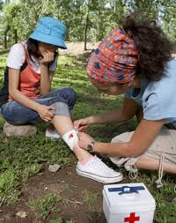



**MODELO 1 TASK 1: EXPRESSION STUDENT B**

**TOPIC: JOBS**

* Talk about the job that you have or would like to have.
* Pros and cons of setting up your own business.
* 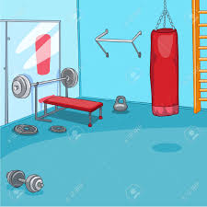A personal anecdote related to the topic.





**MODELO 2 TASK 1: EXPRESSION STUDENT A**

**TOPIC: HEALTH**

* Public versus private health: pros and cons.
* The importance of diet, exercise and sleep for health.
* A personal anecdote related to the topic.







**MODELO 2 TASK 1: EXPRESSION STUDENT B**

**TOPIC: SLEEP**

* Problems related with sleep.
* Do you know anybody who talks in their sleep or sleepwalks? Tell me about them.
* What do you do if you cannot get to sleep?

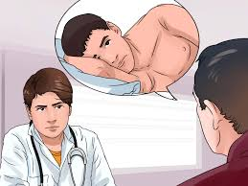

**MODELO 3 TASK 1: EXPRESSION STUDENT A**

**TOPIC: WORK-LIFE BALANCE**

* Are there any differences in the way men and women deal with their work-life balance?
* How do you think flexible working helps to achieve a healthy work-life balance?
* A personal anecdote related to the topic.





**MODELO 3 TASK 1: EXPRESSION STUDENT B**

**TOPIC: PERSONAL IDENTIFICATION**

* Talk about the influence (positive or negative) of celebrities on society, especially on teenagers and young people.
* Think of examples from different fields (sport, entertainment, science, art…) to justify your point.
* Do you think it’s their responsibility to set an example? Why/why not?

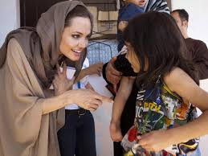

**MODELO 4 TASK 1: EXPRESSION STUDENT A**

**TOPIC: HEALTH**

* Stress can affect the way we behave and even our health. Is life becoming more or less stressful for people?
* Which would you choose: a stressful job with very high pay or a relaxing job with considerably lower pay? Why?
* What advice would you give to someone suffering from stress?



**MODELO 4 TASK 1: EXPRESSION STUDENT B**

**TOPIC: RELATIONSHIPS**

* Talk about how dating and the way couples meet has changed over the last few decades. How did couples use to meet forty years ago?
* Talk about the pros and cons of online dating.
* Have you or anyone you know ever dated someone in an unconventional way? What happened afterwards?





**MODELO 5 TASK 1: EXPRESSION STUDENT A**

**TOPIC: WORK**

* Talk about the challenges young people have to face in today's society.
* Do you know any young person who has emigrated abroad?
* 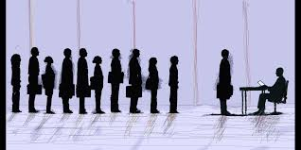Why do people make that decision? Pros and cons of moving abroad.



**MODELO 5 TASK 1: EXPRESSION STUDENT B**

**TOPIC: HEALTH**

* Standard versus alternative medicine: pros and cons.
* What are the risks of having a sedentary lifestyle on your physical and mental condition?
* How can we fight unhealthy habits? Suggest different ways to get fit.



**MODELO 6 TASK 1: EXPRESSION STUDENT A**

**TOPIC: WORK AND EDUCATION**

* What are some of the challenges young people have to face these days?
* Give your view on whether it is easier to find a job if you are highly qualified.
* What advice would you give a teenager who doesn’t know what to do in the future?



**MODELO 6 TASK 1: EXPRESSION STUDENT B**

**TOPIC: ELDERLY PEOPLE**

* How do retired and elderly people live today? (problems, services, quality of life, etc.). Contrast this with life for this age group 50 years ago.
* How can the elderly contribute to our society?
* A personal anecdote related to this topic.



**MODELO EJEMPLO TASK 1: EXPRESSION STUDENT A**

**TOPIC: TECHNOLOGY AND FAMILY LIFE**

* Talk about how technology has changed family life and social relations over the last few years.
* Is technology a part of your daily life? In what way?
* Do you think technology has had a positive or negative impact on people's lives and relationships? Why?



**MODELO EJEMPLO TASK 1: EXPRESSION STUDENT B**

**TOPIC: RELATIONSHIPS**

* How important is an age gap in relationships? Do you think having a big age gap can be a problem for a couple? Why, why not?
* What is the key to a successful relationship at any age?
* 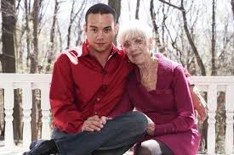Describe your ideal partner.



**MODELO EJEMPLO TASK 2: INTERACTION STUDENT A**

Your town council is planning to organize activities for the citizens three evenings a week and they have invited the residents’ suggestions.

You are discussing this with a friend. You think the activities should concentrate on **the needs of the older people** in town.

Propose two or three activities and say when these activities should take place. Explain your ideas and try to come to an agreement with your friend.

**YOU BEGIN THE DIALOGUE.**

**MODELO EJEMPLO TASK 2: INTERACTION STUDENT B**

Your town council has proposed organizing activities three evenings a week in the town hall and has asked the citizens for suggestions.

You are discussing this with a friend. You think they should concentrate on **the needs of the young people** in town.

Propose two or three activities and say when these activities should take place. Explain your ideas and try to come to an agreement with your friend.

**A BEGINS THE DIALOGUE.**

**MODELO 1 TASK 2: INTERACTION STUDENT A**

You have been unemployed for a long time and finally you have been offered a job in another city.

You have not accepted the job yet because you are still thinking about the financial, professional and personal pros and cons of this job move.

Talk it over with your best friend, because your final decision will be based on your own feelings and your friend’s advice. Explain to him / her why you think that changing now would be **good** for you.

**YOU BEGIN THE DIALOGUE.**

**MODELO 1 TASK 2: INTERACTION STUDENT B**

After being unemployed for a long time, your best friend has been offered a job in another city.

When you think about all the disadvantages and negative aspects that moving away from home might have, you conclude that perhaps it is **not** a good idea for your friend to accept this job.

Talk to him/her about it and try to persuade him / her not to accept the job.

**A BEGINS THE DIALOGUE.**

**MODELO 2 TASK 2: INTERACTION STUDENT A**

**TASK 2: INTERACTION 3 (DIALOGUE)**

You are the **best employee** in an important company and you want to take a year off, but you need the approval of your boss.

Think about different and important reasons why you and your company would benefit from this break.

Discuss your arguments and try to come to an agreement with your boss.

**YOU BEGIN THE DIALOGUE**.

**MODELO 2 TASK 2: INTERACTION STUDENT B**

You are **the boss** of an important company and your best employee wants to take a year off.

You don’t believe it is a good idea for him/her or for the company.

Think about different and important reasons why it is not appropriate to do so.

Discuss your argument and try to reach an agreement with your employee.

**A STARTS THE DIALOGUE.**

**MODELO 3 TASK 2: INTERACTION STUDENT A**

You and your siblings are planning a surprise trip for your parents to celebrate their wedding anniversary.

You think that **a sightseeing tour of several European capitals** would be fantastic for them for many reasons, so you recommend this.

Explain to your brother/sister what your idea is and the reasons why.

Try to come to an agreement.

**YOU BEGIN THE DIALOGUE.**

**MODELO 3 TASK 2: INTERACTION STUDENT B**

You and your siblings are planning a surprise trip for your parents to celebrate their wedding anniversary.

You think that **a cruise to relax in style** would be fantastic for them for many reasons.

Explain to your brother/sister what your idea is and the reasons why.

Try to come to an agreement.

**A BEGINS THE DIALOGUE.**

**MODELO 4 TASK 2: INTERACTION STUDENT A**

Your local high school is planning to organize after-school activities for the children, and they have asked pupils and parents for suggestions.

Each person may choose a maximum of three activities. You prefer non-academic activities, such as cooking or dancing. You are discussing this with a friend.

Choose three activities and explain the reasons for your choice to your friend.

Try to come to an agreement on the three you think would be the best.

**YOU BEGIN THE DIALOGUE.**

**MODELO 4 TASK 2: INTERACTION STUDENT B**

Your local high school is planning to organize after-school activities for the children, and they have asked pupils and parents for suggestions.

Each person may choose a maximum of three activities. You prefer academic activities such as English or a Science club. You are discussing this with a friend.

Choose three activities and explain the reasons for your choice to your friend.

Try to come to an agreement on the three you think would be the best.

**A BEGINS THE DIALOGUE.**

**MODELO 5 TASK 2: INTERACTION STUDENT A**

You haven’t been feeling well recently, and you decide to go to the doctor’s.

When you get there you are told there is a new young doctor and you don’t like the idea very much.

Try to find out as much as you can about his/her training and experience (politely).

Answer any questions the doctor asks, tell him/her the reason for being there and react to the treatment prescribed.

**YOU BEGIN THE DIALOGUE.**

**MODELO 5 TASK 2: INTERACTION STUDENT B**

You’ve just finished medical school and now that you are a doctor you are starting in a new surgery full of enthusiasm.

You always like to find out as much as possible about the patient when you first meet them.

You are a great believer in alternative medicine (homeopathy and acupuncture), specially for particular conditions.

Find out as much information about the patient, the reason why s/he is there today and react accordingly.

**A BEGINS THE DIALOGUE.MODELO 6 TASK 2: INTERACTION STUDENT A**

Your mum, a widow, is getting older and older and cannot live on her own any more. Her neighbours have told you about a few incidents recently that have made you worried about her safety.

You think the best option would be to invite her to live with you and your family (husband/wife and two children) at home.

You love her dearly and she can still help you looking after the children.

Try to persuade your spouse and come to an agreement.

**YOU BEGIN THE DIALOGUE.**

**MODELO 6 TASK 2: INTERACTION STUDENT B**

Your mother-in-law, a widow, is getting older and older and cannot live on her own any more.

You have always had a very good relationship with her, but you think the best option would be to send her to an old people’s home for a number of reasons.

Try to persuade your spouse and come to an agreement.

**A BEGINS THE DIALOGUE.**