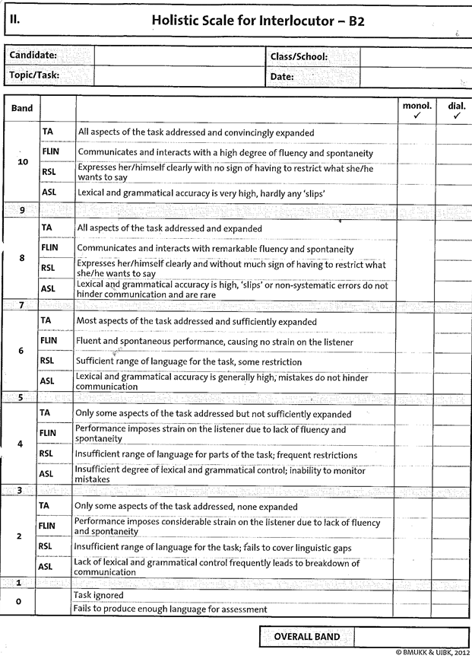

CODE:

TA: TASK ACHIEVEMENT

FLIN:FLUENCY & INTERACTION

RSL:RANGE OF SPOKEN LANGUAGE (STRUCTURES & VOCABULARY)

ASL: ACCURACY OF SPOKEN LANGUAGE

(STRUCTURES & VOCABULARY)

AUSTRIA