DAILY WRITING

Today, I,m________
 |  |  | 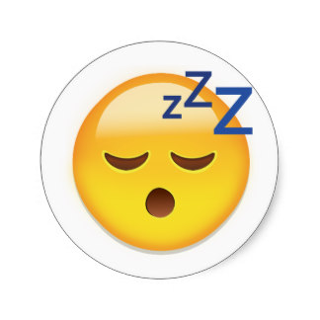
GOOD | ANGRY | SAD | TIRED

Write your daily sentence:

________________________________________________________________________________________________
Ilustrate your sentence:

