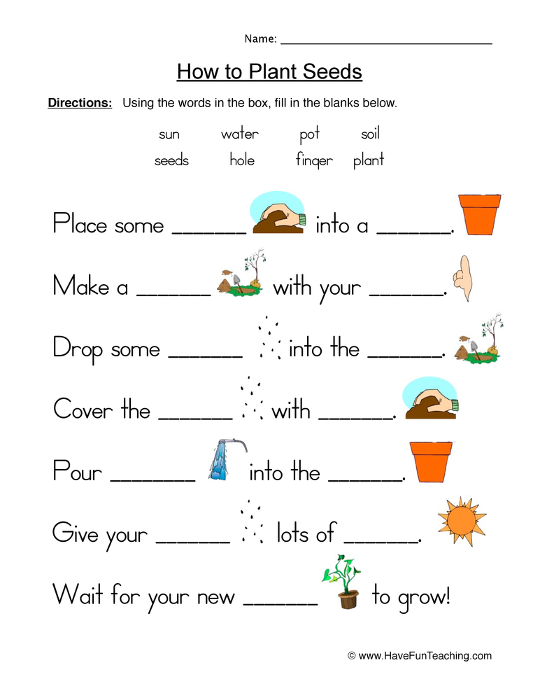

Name: _________________________________________ Level: _____________