CUADERNO DE

ROMA

Nombre:
CURSO:
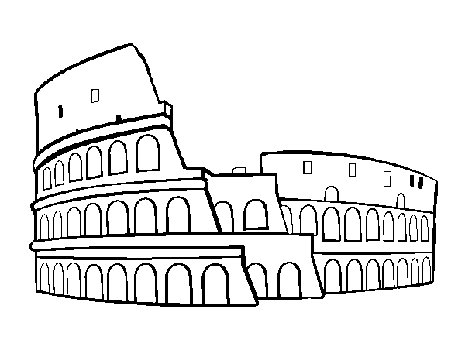

LOS ORÍGENES DE ROMA

LA VESTIMENTA ROMANA

LA GASTRONOMÍA ROMANA: _________________________________________________________________________________________________________________________________________________________________________________________________________________________________________________________________________________________________________________________________________________________________________________________________________________________________________________________________________________________________________________________________________________________________________________________________________________________________________________________________________________________________________________________________________________________________________________________________________________________________________________________________________________________________________________________.

Cocinamos una receta romana:Nombre:________________________________________________________________________________________________________________________
Ingredientes:_____________________________________________________________________________________________________________________
Utensilios:_______________________________________________________________________________________________________________________
Tiempo de preparación:____________________________________________________________________________________________________________________________________________________________________________________________________________________________________________________________________________________________________________________________________________________________________________________________________________________________________________________________________________________________________________________________________________________________________________________________________________________________________________________________________________________________________________

LA MONEDA ROMANA:

LAS CONSTRUCCIONES ROMANAS:
Escribe el nombre de estas construcciones y di todo lo que sepas sobre ellas.

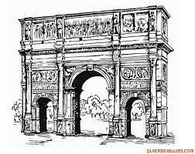

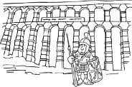

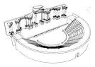

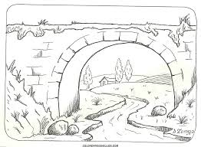

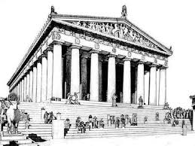

LA RELIGIÓN EN ROMA:

LA SOCIEDAD:

LOS NÚMEROS ROMANOS

NUESTRAS OBRAS ARTÍSTICAS

VISITAS DESDE ROMA

LOS JUEGOS ROMANOS

ARUCCI TURÓBRIGA

EMERITA AUGUSTA

