1ºF TEAM PROJECT: PLAYING TO BE HEALTHY.
Goals:
- Learning about healthy food to improve our life style.
- Distinguishing between countables /uncountables in the food context.
- Using quantifiers with food properly.
- Learning the importance of tea in English life and knowing the main dishes in British culture.
- Designing Easter Eggs in a funny way.
- Learning how to cook the popular mugcakes.
- Singing along “Monster Mash” ( by Bobby “Boris” Pickett): a song about monsters to mark the 200th anniversary of the creation of Frankenstein by Mary Shelly.

Teams (1ºF):

Team 1: Manuel Morgado, Daniel Fernández, Karina Clemente , Fabiola Prieto. | Team 2: Nadia Cortés, Curro Ponce, Pablo Tocino, Marta Elías. | Team 3: Alejandra Pérez, Marta Borrallo, Airám Faraj, Marcial Clemente.
Team 4: Minerva Barrera, Raquel Bohórquez, Marcos Martín, Jesús García, Elea Redondo. | Team 5: Oliver Serrano, valeria Vázquez, Andrea Brioso, Älvaro Carrasco, Lucía González. | Team 6: Juan Mª Ibáñez, Francisco Acebedo, Patricia Sánchez, Nourdine Yahía, Denia Rodriguez.

GROUP NUMBER: .......................
ACTIVITY 1: LET´S PLAY WITH SHOPPING
Have a look to your basket, identify the food and copy the words in English in the following shopping list, using the quantifiers: a/an/some. Then classify the food items into: Countables or Uncountables. Use a dictionary if necessary. Let´s go to the point !

MY SHOPPING LIST

GROUP NUMBER:__________
CLASSIFICATION
COUNTABLES UNCOUNTABLES

Now, look at your shopping list again and select food items to cook a recipe you like. Copy the ingredients and explain the recipe step by step.
RECIPE:.................................................................................
INGREDIENTS:
________________________________________________________________________________
PROCESS:________________________________________________________________________
________________________________________________________________________________
________________________________________________________________________________
________________________________________________________________________________
GROUP NUMBER: __________
QUESTIONNAIRE: HISTORY AND TYPES OF TEA | 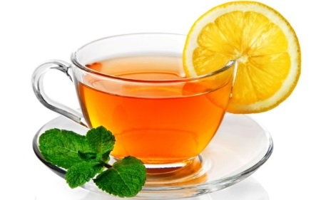
1- Where is tea from?
a) Britain
b) China
c) Portugal
2- How was tea used before being considered a drink?
a) as garden decoration
b) as plant to feed animals
c) as medicine
3- When was tea popular in Britain?
a) During the 15th century
b) In the 1st part of 16th century
c) By the end of 17th century
4- Who drank tea by that time?
a) poor people
b)rich people
c) everybody
5- What time is tea usually served?
a) at 3 o´clock
b) at four o´clock
c) at 5 o´clock
6- What is a scone?
a) a tea room
b) a cake
c) a plant

7- What type of tea is the most expensive?
a) Oolong tea
b)white tea
c) black tea
8- What type of tea has digestive beefits?
a) Oolong tea
b) green tea
c) black tea
9- What is the utensil to separate tea leaves from water?
a) strainer
b) teapot
c) tea cup
10- How must be the water to prepare a cup of tea?
a) cold
b) boiling
c) frozen

