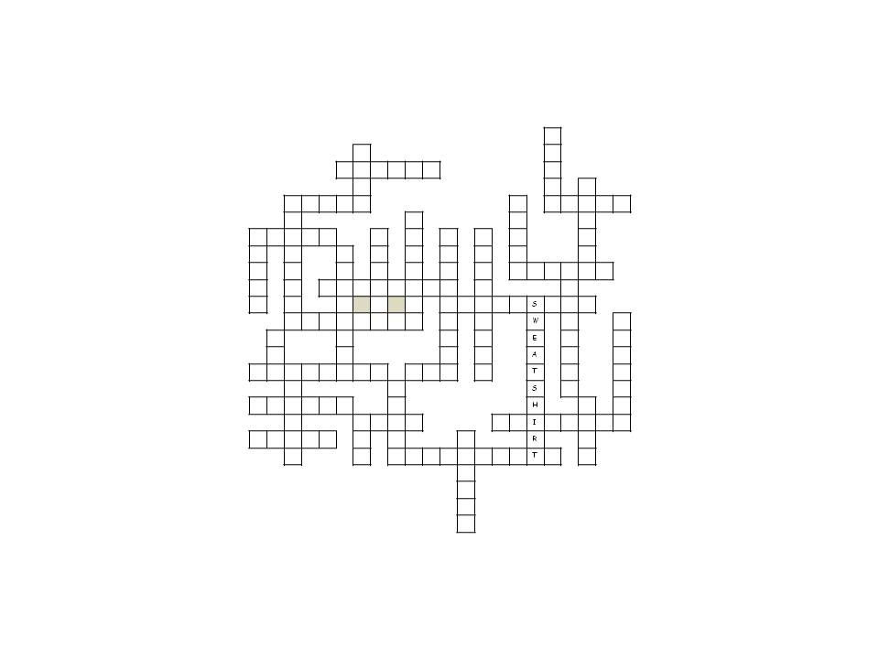

**3 letters**

___ hat

___ cap

___ tie

**4 letters**

___ coat

___ suit

___ belt

**5 letters**

___ boots

___ jeans

___ dress

___ shirt

___ skirt

___ shoes

___ scarf

___ socks

**6 letters**

___ shorts

___ gloves

___ jacket

___ t-shirt

___ anorak

___ jumper

___ blouse

**7 letters**

___ mittens

___ pyjamas

**8 letters**

___ trousers

___ raincoat

___ cardigan

___ leggings

___ slippers

___ trainers

___ swimsuit

**9 letters**

___ tracksuit

___ waistcoat

___ dungarees

**10 letters**

___ swim shorts

1 sweatshirt



Match the words to their pictures and solve the puzzle

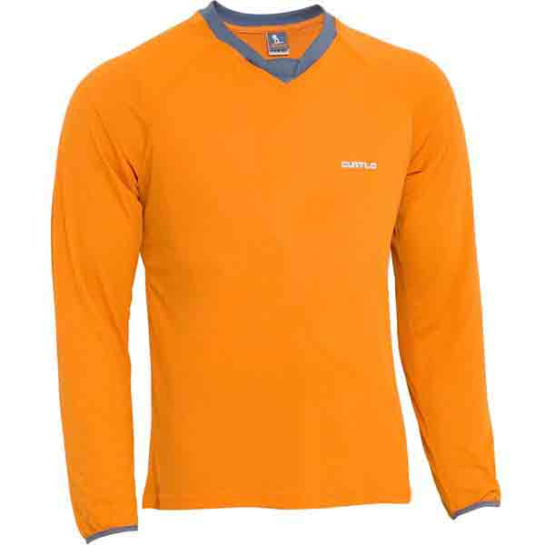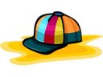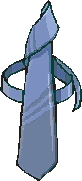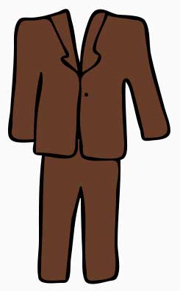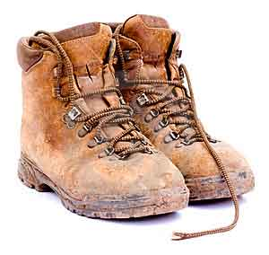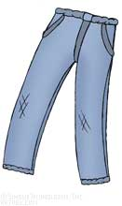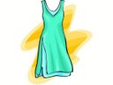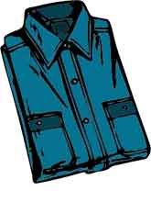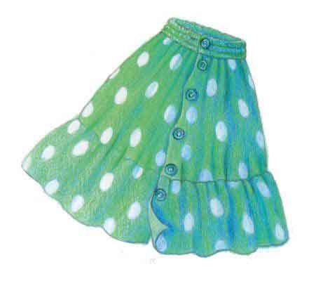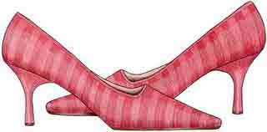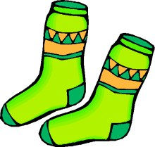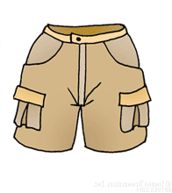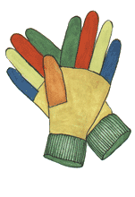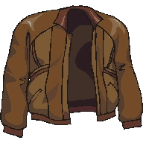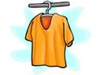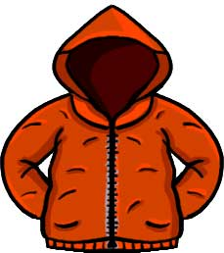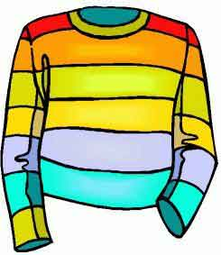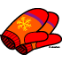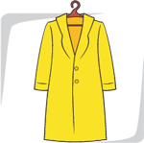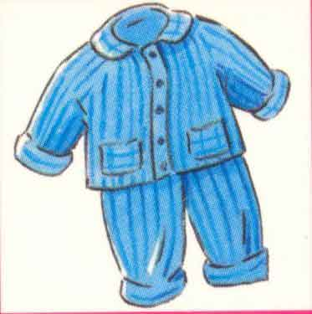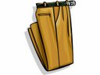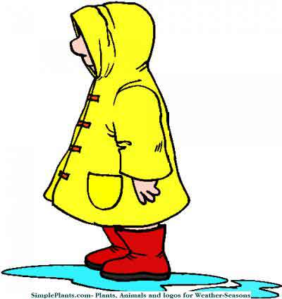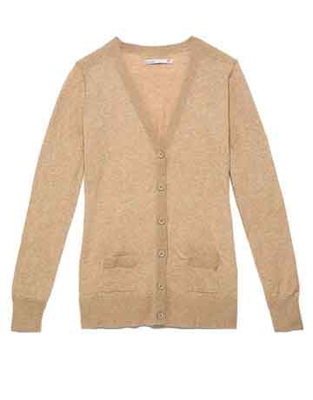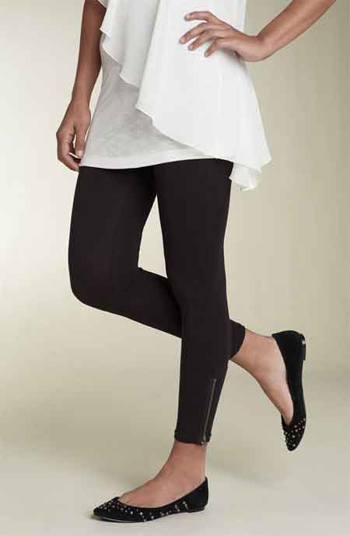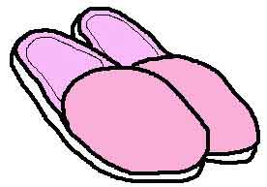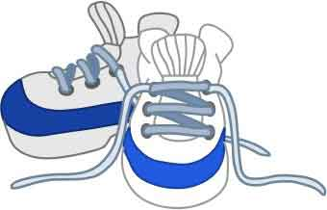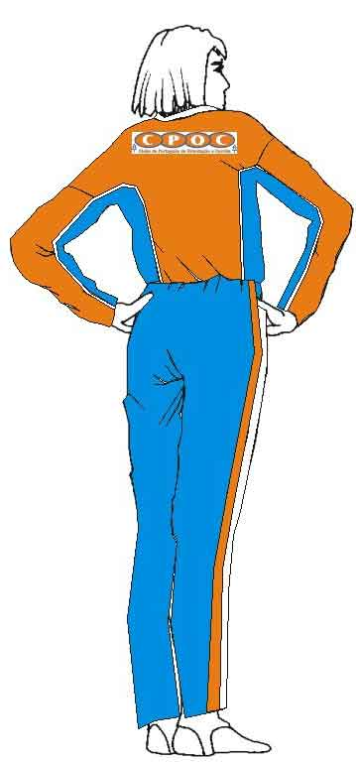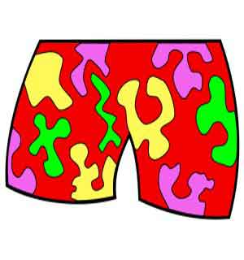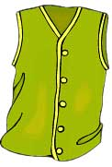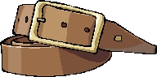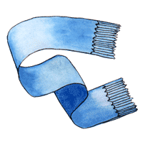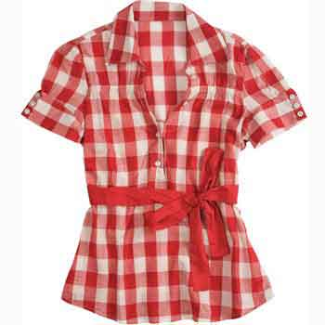

**KEY:**

|  |  |  |  |  |  |  |  |  |  |  |  |  |  |  |  |  |  |  |  |  |  |
| --- | --- | --- | --- | --- | --- | --- | --- | --- | --- | --- | --- | --- | --- | --- | --- | --- | --- | --- | --- | --- | --- |
|  |  |  |  |  |  |  |  |  |  |  |  |  |  |  |  |  | **S** |  |  |  |  |
|  |  |  |  |  |  | **S** |  |  |  |  |  |  |  |  |  |  | **O** |  |  |  |  |
|  |  |  |  |  | **J** | **U** | **M** | **P** | **E** | **R** |  |  |  |  |  |  | **C** |  |  |  |  |
|  |  |  |  |  |  | **I** |  |  |  |  |  |  |  |  |  |  | **K** |  | **J** |  |  |
|  |  | **S** | **H** | **I** | **R** | **T** |  |  |  |  |  |  |  |  | **B** |  | **S** | **C** | **A** | **R** | **F** |
|  |  | **W** |  |  |  |  |  |  | **M** |  |  |  |  |  | **O** |  |  |  | **C** |  |  |
| **S** | **K** | **I** | **R** | **T** |  |  | **B** |  | **I** |  | **W** |  | **D** |  | **O** |  |  |  | **K** |  |  |
| **H** |  | **M** |  |  | **C** |  | **L** |  | **T** |  | **A** |  | **U** |  | **T** |  |  |  | **E** |  |  |
| **O** |  | **S** |  |  | **A** |  | **O** |  | **T** |  | **I** |  | **N** |  | **S** | **H** | **O** | **R** | **T** | **S** |  |
| **E** |  | **U** |  | **T** | **R** | **O** | **U** | **S** | **E** | **R** | **S** |  | **G** |  |  |  |  | **A** |  |  |  |
| **S** |  | **I** |  |  | **D** |  | **S** |  | **N** |  | **T** | **R** | **A** | **C** | **K** | **S** | **U** | **I** | **T** |  |  |
|  |  | **T** | **R** | **A** | **I** | **N** | **E** | **R** | **S** |  | **C** |  | **R** |  |  | **W** |  | **N** |  |  | **P** |
|  | **T** |  |  |  | **G** |  |  |  |  |  | **O** |  | **E** |  |  | **E** |  | **C** |  |  | **Y** |
|  | **I** |  |  |  | **A** |  |  |  |  |  | **A** |  | **E** |  |  | **A** |  | **O** |  |  | **J** |
| **L** | **E** | **G** | **G** | **I** | **N** | **G** | **S** |  | **H** | **A** | **T** |  | **S** |  |  | **T** |  | **A** |  |  | **A** |
|  |  | **L** |  |  |  |  |  | **J** |  |  |  |  |  |  |  | **S** |  | **T** |  |  | **M** |
| **A** | **N** | **O** | **R** | **A** | **K** |  |  | **E** |  |  |  |  |  |  |  | **H** |  |  | **B** |  | **A** |
|  |  | **V** |  |  |  | **C** | **O** | **A** | **T** |  |  |  |  | **S** | **L** | **I** | **P** | **P** | **E** | **R** | **S** |
| **D** | **R** | **E** | **S** | **S** |  | **A** |  | **N** |  |  |  | **T** |  |  |  | **R** |  |  | **L** |  |  |
|  |  | **S** |  |  |  | **P** |  | **S** | **W** | **I** | **M** | **S** | **H** | **O** | **R** | **T** | **S** |  | **T** |  |  |
|  |  |  |  |  |  |  |  |  |  |  |  | **H** |  |  |  |  |  |  |  |  |  |
|  |  |  |  |  |  |  |  |  |  |  |  | **I** |  |  |  |  |  |  |  |  |  |
|  |  |  |  |  |  |  |  |  |  |  |  | **R** |  |  |  |  |  |  |  |  |  |
|  |  |  |  |  |  |  |  |  |  |  |  | **T** |  |  |  |  |  |  |  |  |  |