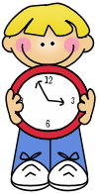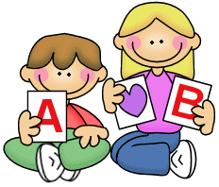

1. Write the adjectives in brackets in the Comparative form.
2. John Lennon was (OLD) __________ Paul McCartney.
3. Some people think the Met is (GOOD) ___________ the Louvre.
4. Eric was (AFRAID) ______________ in Harlem _____ in the Subway.
5. Cats are (NICE) ___________ dogs.
6. Cartoons are (GOOD) _____________ music programmes.
7. The Empire State is (BIG) _____________ the Chrysler Building.
8. Barcelona is (SMALL) ________________ Madrid, but (BIG) ___________ Valencia.
9. Write the adjectives in brackets in the Superaltive form.
10. Samantha is the (PRETTY) __________ girl that Paul has ever met.
11. I think that King Kong was the (BAD) _____________ film ever!
12. Mounth Everest is the (HIGH) ____________ mountain in the world.
13. Our English teacher is the (GOOD) _____________ teacher ever!
14. My room is the (CLEAN) ______________ room in my house.
15. Ron is the (CLEVER) _______________ person I’ve ever met.
16. The Millenium Star is one of the (EXPENSIVE) _______________ diamonds in the world.
17. Write the sentences in the correct order.
18. are / than / faster / Cars / bikes.
19. interesting / is / than /more / History / Maths.
20. than / is / exciting / New York / Albany.
21. than / funnier / Comics / magazines / are
22. Japan / expensive / the / country. / is /most
23. Complete the table. Pay attention and don’t forget *than* or *the*.

|  |  |  |
| --- | --- | --- |
| ADJECTIVE | COMPARATIVE | SUPERLATIVE |
| Good |  |  |
|  | Nicer than |  |
|  |  | The most annoying |
|  | Cheaper than |  |
| Expensive |  |  |
| Bad |  |  |
|  | Bigger |  |
|  |  | The tallest |
|  | Prettier |  |
| Fast |  |  |
|  | Happier |  |
|  |  | The smallest |
|  | Sadier |  |
| Boring |  |  |

