At the restaurant 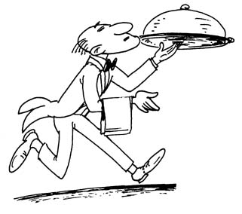
Number the sentences in the dialogue in the correct order.
____ Client: Waiter, I’m ready to order now.
____ Waiter: Cajun chicken? It’s very spicy, grilled chicken.
____ Waiter: The ‘soup of the day’ today is cream of pea soup.
____ Waiter: Ok, what about the main course?
_1__ Waiter: Good evening. Here’s your menu. Let me know when you’re ready to order.
____ Client: Let’s see . . . what is Cajun Chicken?
____ Client: Spicy? In that case, I think I’ll have the baked salmon with brussels sprouts.
____ Waiter: Ok, what will you have?
____ Waiter: Ok, I’ll have your soup in a minute.
____ Waiter: Ok, so potato soup to start and then baked salmon and brussels sprouts with mineral water.
____ Waiter: Ok, and what would you like to drink?
____ Client: What is the ‘soup of the day’ today?
____ Client: I would like mineral water to drink, please.
____ Client: Yes, that’s right.
____ Client: Oh, I don’t like pea soup. I think I’ll have potato soup instead.

At the restaurant (answer key)
Waiter: Good evening. Here’s your menu. Let me know when you’re ready to order.
Client: Waiter, I’m ready to order now.
Waiter: Ok, what will you have?
Client: What is the soup of the day?
Waiter: The soup of the day today is cream of pea soup.
Client: Oh, I don’t like pea soup. I think I’ll have potato soup instead.
Waiter: Ok, what about the main course?
Client: Let’s see . . . what is Cajun Chicken?
Waiter: Cajun chicken? It’s very spicy, grilled chicken.
Client: Spicy? In that case, I think I’ll have the baked salmon with brussels sprouts.
Waiter: Ok, and what would you like to drink?
Client: I would like mineral water to drink, please.
Waiter: Ok, so potato soup to start and then baked salmon and brussels sprouts with mineral water.
Client: Yes, that’s right.
Waiter: Ok, I’ll have your soup in a minute.

