Match the words to the correct pictures and complete the crossword. Then find a secret message.

**cat**

**cow**

**dog**

**donkey**

**elephant**

**frog**

**giant panda**

**giraffe**

**goat**

**horse**

**kangaroo**

**koala**

**ladybird**

**lion**

**monkey**

**mouse**

**penguin**

**rabbit**

**shark**

**tiger**

**whale**

**zebra**

The secret message is _________ __________ _________ _________ ________ ________ **summer.**

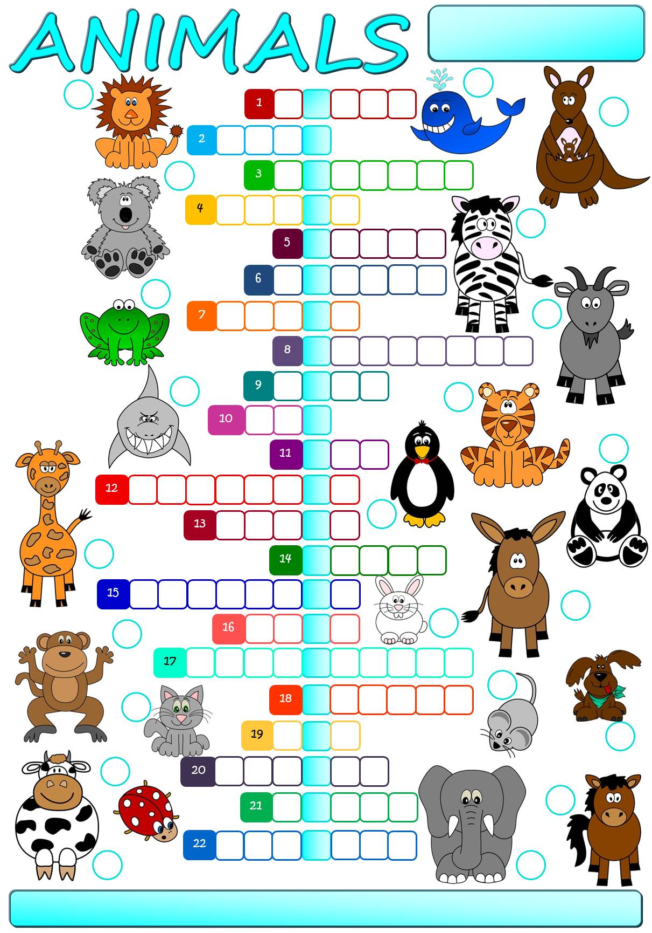

Match the words to the correct pictures and complete the crossword. Then find a secret message.

**cat**

**cow**

**dog**

**donkey**

**elephant**

**frog**

**giant panda**

**giraffe**

**goat**

**horse**

**kangaroo**

**koala**

**ladybird**

**lion**

**monkey**

**mouse**

**penguin**

**rabbit**

**shark**

**tiger**

**whale**

**zebra**

The secret message is _________ __________ _________ _________ ________ ________ **summer.**

R

**N**

**E**

**S**

**W**

**A**

**L**

**L**

**O**

**W**

**D**

**O**

**E**

**S**

**N**

**O**

**T**

**M**

**A**

**K**

**E**

H

S

**O**

E

I

P

O

Match the words to the correct pictures and complete the crossword. Then find a secret message.

L

N

G

U

O

M

E

E

H

A

B

R

T

A

K

O

B

I

A

D

Y

G

A

P

C

O

R

O

A

G

G

I

H

A

T

E

A

G

R

G

P

I

O

N

E

T

O

D

Z

R

A

**A**

R

F

F

E

I

G

A

N

C

B

F

N

**cat**

**cow**

**dog**

**donkey**

**elephant**

**frog**

**giant panda**

**giraffe**

**goat**

**horse**

**kangaroo**

**koala**

**ladybird**

**lion**

**monkey**

**mouse**

**penguin**

**rabbit**

**shark**

**tiger**

**whale**

**zebra**

B

K

U

I

N

L

A

D

R

T

N

K

A

T

R

R

K

H

P

L

E

A

N

D

A

Y

Y

E

G

I

The secret message is **One swallow does not make a summer.**

