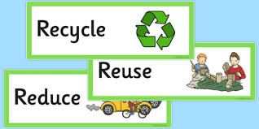

WHAT IS ABOUT THIS PICTURE?

