º

**HEIGHT**

Fat, Enormous,

Pudgy, Chubby, Strong, Athletic, Voluminous/Massive, Thin, Slim, Weak, Tiny, Small

**CORPULENCE**

Fat, Enormous,

Pudgy, Chubby, Strong, Athletic, Voluminous/Massive, Thin, Slim, Weak, Tiny, Small

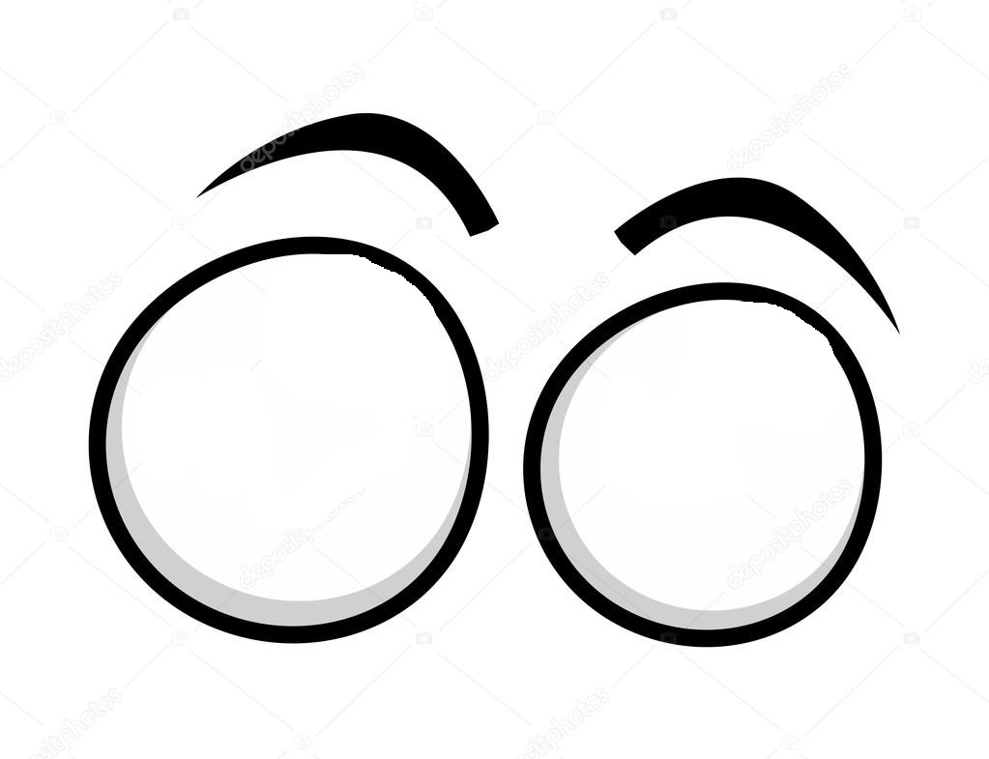

Big,

Excessive,

Enormous, Giant, Small, Tiny, Microscopic,

Little

**SIZE**



Round,

Slanted eyes, Almond eyes,Bulging eyes, Separate eyes, ,

Squinting eyes

**SHAPE**



Bright eyes, Brown/ Blue/Green/Dark

eyes

**COLOUR**

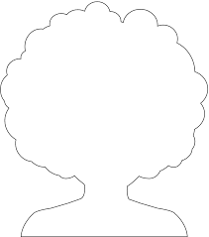

Fair/ Blond hair, Dark/Brown/Red/Grey hair

**COLOUR**



Long,

Short,

Shoulder length, Bald

**LENGTH**



Straight hair, Curly hair, Wavy hair, Frizzy hair, Fringe

**SHAPE**

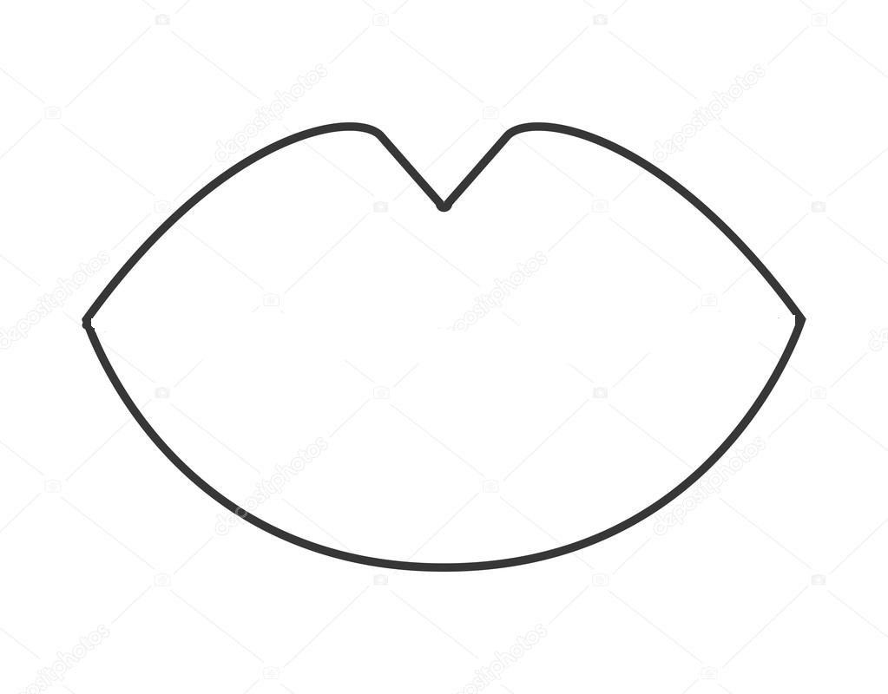

Big lips, Enormous lips,

Small lips, Tiny lips,

Thick lips, Fine lips, Fleshy lips

**SIZE**



Big, Small, White, Dirty, Clean, Plaqued teeth, Chopped, Broken, Fake teeth, Crooked, Straight teeth, Uneven teeth, Rabbit teeth

**TEETH**