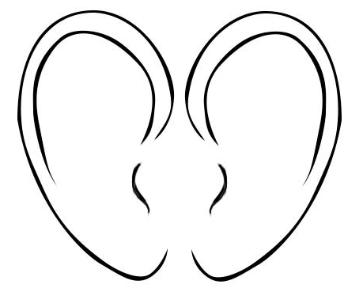

Satyr-like.

Wiged ears.

Big.

Small.

Pendant. Pointy. Drooping.