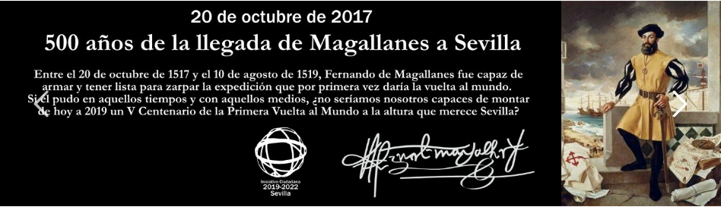

https://www.youtube.com/watch?v=gqPvBy5O3QI
http://olmo.pntic.mec.es/jtac0001/historia/exploradores/circunnavega.htm
https://showerofroses.blogspot.com.es/2011/11/new-world-explorers-unit-study-and-lap.html
https://www.youtube.com/watch?v=rKg_kNpsEZI
http://olmo.pntic.mec.es/jtac0001/historia/exploradores/circunnavega.htm

http://manuelblascinco.blogspot.com.es/2014/12/magallanes-y-elcano-la-primera-vuelta.html
https://www.youtube.com/watch?v=C0uv8Y8TZFI

http://catigui.wixsite.com/earthquestlavuelta

https://tomasmazon.wixsite.com/primeravueltalmundo/la-primera-vuelta-al-mundo

http://edu.glogster.com/glog/ferdinand-magellan/15dxs723hh6

