Name:_ Surname: Date: Class:
NATURAL SCIENCE EXAM UNIT 3 6TH GRADE
1.- Draw an animal cell and a plant cell, label their parts and describe them:

Nucleus:___________________________________________________________
Membrane:________________________________________________________
Cytoplasm:________________________________________________________

2.- What do you use a microscope for? Label its parts.

3.- Say True or False, and correct the false sentences:
- Bacteria is an example of Virus. ________________________________________________________
- Viruses cause health. _________________________________________________________________
- Viruses reproduce only by infecting living cells. ____________________________________________

4.- Complete the table:
KINGDOMS: | Unicellular/ Multicellular | Heterótrofas/Autótrofas | Examples:
Monerans
Protists
Fungi
Animals
Plants

5.- Label and order these elements from the simplest to the most complex:
CELL - TISSUE - ORGAN - SYSTEM
________________ _______________ ______________ _______________

6.- Fill in the gaps.
All organisms are made up of _____________.
Cells store genetic information in the ___________________.
Cells are full of a liquid called __________________________.
Organisms made up of only one cell are __________________.
Organisms made up of many different kinds of cells are _______________.
Algae can make their own food because they have ___________________.
NUCLEUS – CYTOPLASM – CHLOROPLASTS – UNICELLULAR – CELLS – MULTICELLULAR

7.- Complete the information about viruses.
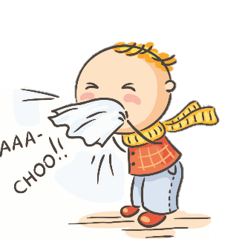
VIRUSES: are __________, which are not considered to be alive. Viruses are ________ and simpler than any cell.
They can ___________ by infecting living cells.
Most viruses cause diseases. Virus can have many different __________.

