NATURAL SCIENCE 6th grade – Unit 3 : LIVING THINGS (I).
MICROSCOPES are instruments to see things that are too small for our eyes to see.
OBJECTIVE
LENSES
EYEPIECE
A sample is a small piece of the material that you want to look at.
CELLS:
All living things are made up of tiny things called cells. Cells are living things and they carry out the three life processes: nutrition, sensitivity and reproduction.
SLIDE
Animals and plants have a similar structure:
STAGE
- Nucleus: controls what happens in the cells. Genetic information is stored here.
- Organelles are the organs of the cells.
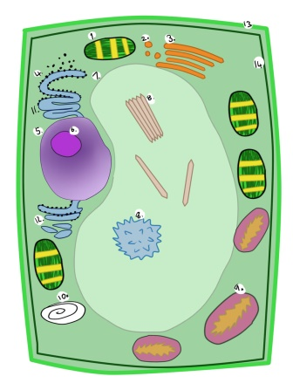
- Cytoplasm: a jelly-like liquid inside the cell.
- Membrane: is the skin of the cell.
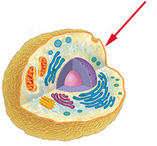
Animal cells: are smaller and usually have an irregular shape.
Plant cells: are bigger and usually have a regular shape. Chloroplasts allow plants to produce their own food through photosynthesis.
UNICELLULAR OR MULTICELLULAR:
Unicellular: have one cell. Like Microbes. Multicellular: are made up of many different kinds of cells. Organisation:
CELL TISSUE ORGAN SYSTEM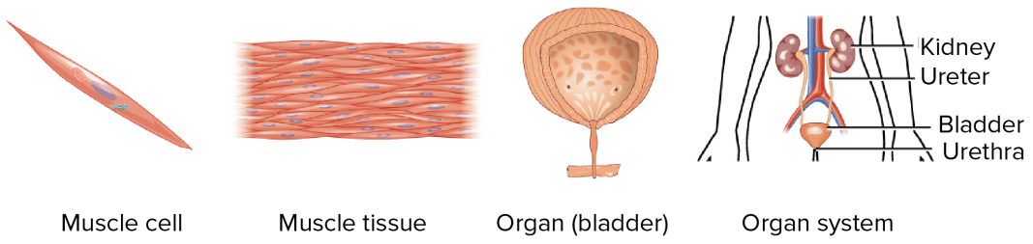
THE FIVE KINGDOMS:
Animals and plants are living organisms. But there are other life forms:
 | MONERA | PROTISTS | FUNGI | PLANTS | ANIMALS
K  I  N  G  D  O  M | 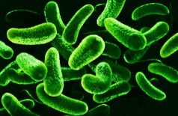  Bacteria | 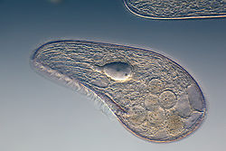  Protozoa | Yeast  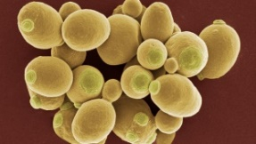 | Plants have stems, roots, leaves and seeds  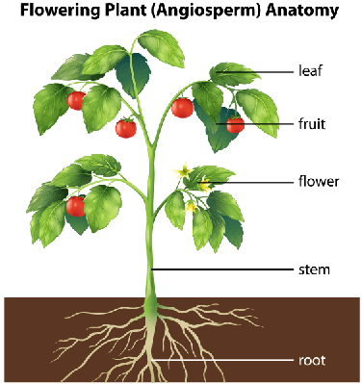 | Invertebrates  Vertebrates
 |  | Algae  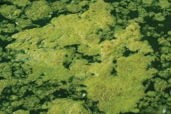 | Mould  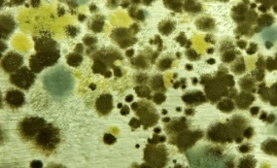
Mushrooms
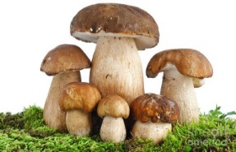

ORGANI  SATION | Unicellular | Unicellular and multicellular | Unicellular and multicellular | Multicellular | Multicellular
N  U  T  R  I  T  I  O  N | They feed on organic matter (heterótrofas) | Protozoa:feed on organic matter (heterótrofas).  Algae: can make their own food  (autótrofas). | They feed on dead organic matter. (heterótrofas) | They can make their own food through photosynthesis. (autótrofas). | They feed on other living things. (heterótrofos)
VIRUSES: are microbes, which are not considered to be alive. Viruses are smaller and simpler than any cell.
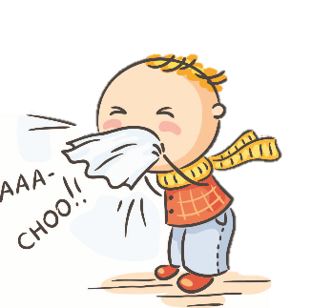
They can reproduce by infecting living cells.
Most viruses cause diseases. Virus can have many different shapes.

