NATURAL SCIENCE 6th grade – Unit 3 : LIVING THINGS (I).
MICROSCOPES are instruments that allow us to see things that are too small for our eyes to see. They have magnifying lenses.
A sample is a small piece of the material that you want to look at.
CELLS:
All living things (also known as organisms) are made up of tiny things called cells. Cells are living things too, and they carry out the three life processes: nutrition, sensitivity and reproduction.
Animals and plants have a similar structure:
- Nucleus: controls what happens in the cells. Genetic information is stored here.
- Organelles are the organs of the cells.
- Cytoplasm: a jelly-like liquid inside the cell.
- Membrane: is the skin of the cell.
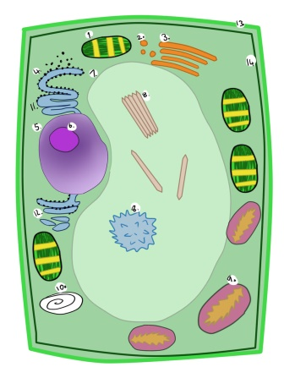
Cells from different parts of a plant or an animal have different shapes.
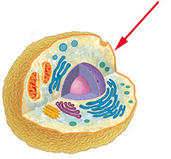
Animal cells: are smaller and usually have an irregular shape.
Plant cells: are bigger and usually have a regular shape. Chloroplasts allow plants to produce their own food through photosynthesis.
Plants cells are surrounded by a hard cell wall.
UNICELLULAR OR MULTICELLULAR:
Most organisms, like animals and plants, have many cells. They are multicellular. But some organisms have only one cell and are only visible through a microscope. They are unicellular.
Unicellular: have one cell. This cell carries out three life processes: nutrition, sensitivity and reproduction. (Microbes).
Multicellular: are made up of many different kinds of cells. Organisation:
CELL – TISSUE – ORGAN - SYSTEM
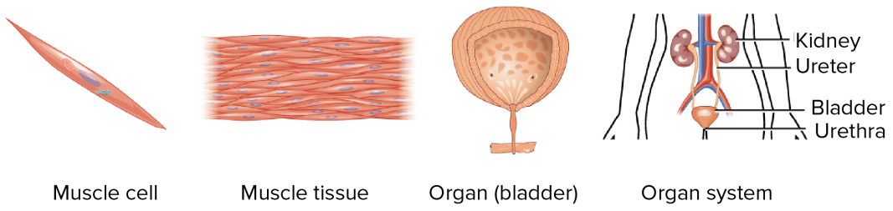
THE FIVE KINGDOMS:
Animals and plants are living organisms. But there are other life forms:
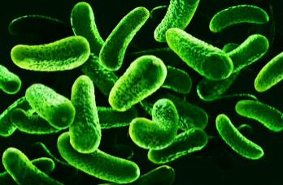
- MONERANS: can live anywhere. Bacteria are the most common monerans and they are the smallest living organisms that exist. Bacteria are unicellular. They feed on organic matter (heterótrofas). Some can move by themselves. Many bacteria are useful, and very few are harmful.

- PROTISTS: live in water or wet places. There are two types:
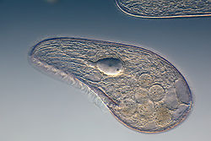
  - Protozoa: are unicellular. They feed on organic matter (heterótrofas). Most can move by themselves
  - Algae: have chloroplasts, so they can make their own food, like plants (autótrofas). They can be unicellular or multicellular.

- FUNGI: live in land habitats. They feed on dead organic matter. There are 3 main groups:
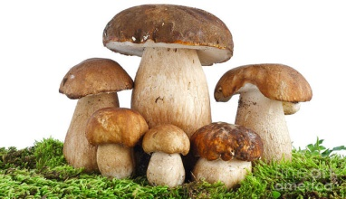
  - Yeast: unicellular. We use some kinds to make bread, beer, wine,…
  - Mould: multicellular. Some are good to eat. Others are used to make medicine.
  - Mushrooms: multicellular. Some are poisonous. Some are edible.

- PLANTS: are multicellular organisms. They can make their own food through photosynthesis. Plants have stems, roots, leaves and seeds.

- ANIMALS: are complex multicellular organisms. They feed on other living things. They can be vertebrates or invertebrates.
VIRUSES:
Are the only microbe that is not considered to be part of the five kingdoms because they are not considered to be alive. Viruses are smaller and simpler than any cell. They do not need to eat and can reproduce only by infecting living cells. Most viruses cause diseases. Virus can have many different shapes.

