Cole Slaw

133 Reviews

Recipe courtesy of Robert Irvine
Show: Dinner: Impossible
Episode: Miles Off the Coast: Fundraiser: Impossible
SAVE RECIPE PRINT
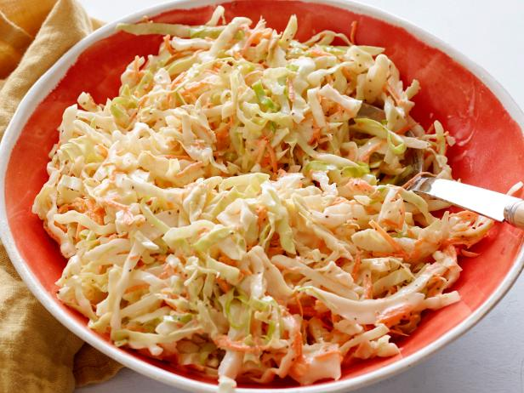
Total:
20 min
Active:
20 min
Yield:
12 servings
Level:
Easy

Ingredients

- 6 cups shredded cabbage
- 1 cup shredded carrot
- 1 cup mayonnaise
- 1/4 cup white wine vinegar
- 1 teaspoon celery seed
- 1/4 cup sugar
- Salt and pepper
ADD CHECKED ITEMS TO GROCERY LIST

Directions
In a large bowl, combine cabbage and carrots. In a smaller bowl, make dressing by combining mayonnaise, vinegar, celery seed, sugar, salt and pepper. Toss dressing into cabbage mixture and let chill. Serve in a family style bowl.

