Tomato sauce
You'll never buy ready-made jars of pasta sauce again after trying this simple, easy blend with garlic and oregano
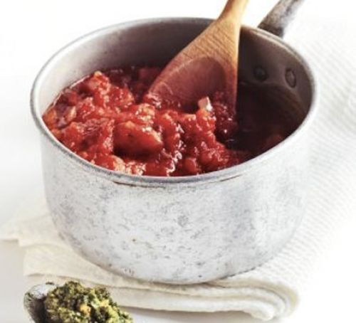

Ingredients
- 1 tbsp olive oil
- 2 onions , chopped
- 2 garlic cloves, crushed
- 1 tbsp tomato purée
- 2 x 400g cans chopped tomatoes
- 1 tsp dried oregano
Method
- Heat the olive oil in a large saucepan, add the onions and cook on a low heat until soft. Add the garlic and tomato purée. Cook for a few minutes then add the chopped tomatoes and oregano. Season generously and simmer for 20 mins, then allow to cool.
- Store in sterilised jars in the fridge for up to 1 week, or transfer to a container and freeze for up to 2 months.

