[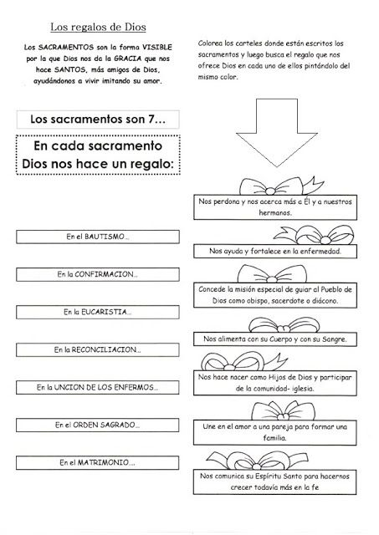](https://www.google.es/url?sa=i&rct=j&q=&esrc=s&source=images&cd=&cad=rja&uact=8&ved=0ahUKEwiVl4Wf9M3YAhWBOxQKHfldBs4QjRwIBw&url=https%3A%2F%2Fwww.pinterest.com%2Fpin%2F809029520530965039%2F&psig=AOvVaw1goFjCOHfinXzf99nJVw78&ust=1515691290045227)