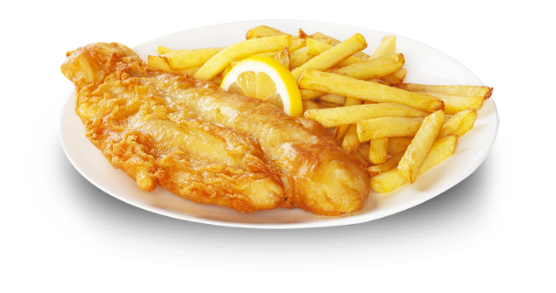

INGREDIENTS

* .
* .
* .
* .
* .
* .
* .
* .

***RECIPE NAME, Authors (4 servings)***

Recipe for X serves. Approximated price: XX€/ £XX

DIRECTIONS