Listen to Christine describing her three-week trip to Italy and choose the appropriate answer to the following questions. Write your answers in the grid provided.

1. Christine
a) already knew the other girl she travelled with
b) had already taken part in a study-abroad program
c) had wished to go to Europe all her life
d) had already travelled abroad

2. When they first arrived in Italy, the first thing that surprised them was that
a) people were very loud and strident
b) there was a lot of traffic
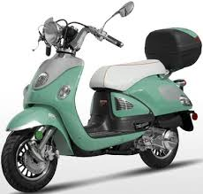
c) she couldn’t understand any Italian at all
d) everything was confusing and chaotic

3. When it comes to the foreign language,
a) they could communicate using English and didn’t have any trouble
c) her friend could speak Spanish and someone had told them that Spanish and Italian are very similar
c) she had taken a year of Italian at high school
d) she had taken a year of Spanish at high school

4. In Rome
a) teenagers are allowed to drive mopeds at the age of 16
b) traffic rules are arbitrary
c) people seem not to embrace traffic rules
d) pedestrians have the right to pass

5. If she went back to Europe
a) she would slow down the pace of the tour
b) she might spend more time in Florence
c) she wouldn’t choose to travel with a group of people
d) she would stay in more confortable hotels

6. She really enjoyed her time in Europe
a) but she did not see everything she wanted to
b) even though she missed the US
c) and came to the decision of moving there
d) and, therefore is preparing her next visit

7. What is her general opinion of her trip?
- It was quite a good experience
- It was overwhelming
- It was really amazing
- It could have been better

Questions | 1 | 2 | 3 | 4 | 5 | 6 | 7
Answers

