EXPRESIÓN ORAL
Give a presentation
ARE YOU FOR OR AGAINST THE FOLLOWING STATEMENTS?
Choose three of them. Use specific reasons and examples to support your answer
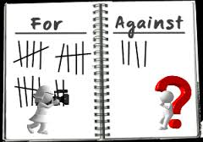
1. Celebrities get what they deserve. They use the press to become famous, so it’s normal that the paparazzi continue to follow them around when they are famous
2. The press should always be free to write what they like
3. Famous politicians or writers have more right to privacy than famous actors or singers
4. “If you don’t read newspapers you are uninformed. If you do read the newspapers you are misinformed” (Mark Twain)
5. Why should we give money to countries that have suffered natural disasters on the other side of the world when there are people who need help closer to home?
6. Talk about a natural disaster that happened recently and that you know well. Provide information about the damage, the casualties and the consequences for the population.
7. Talk about a recent news in your home area or town. Provide details about the facts and say why it concerns you.
8. Everybody is worried about global warming and the future of the planet, but nobody is really prepared to change their lifestyle to help the situation.

ORAL INTERACTION
Read this statement. Decide what your opinion is, take notes and discuss your opinion with your partner(s).
“There should be more control of what you can see and do on the Internet.”

