Portrait of Marie Antoinette and her children by Louise Elisabeth Vigée-Lebrun
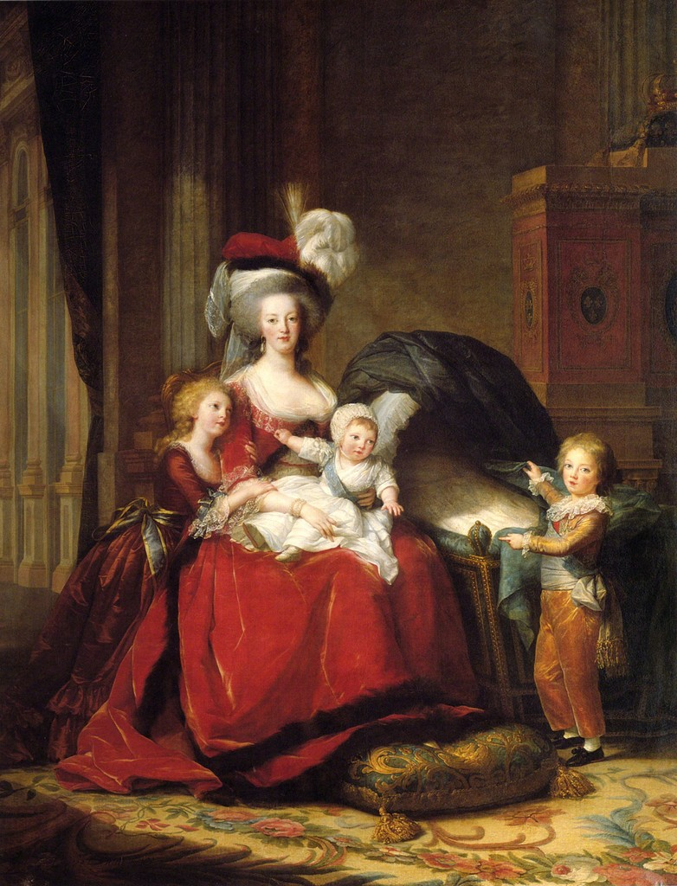

Élisabeth Louise Vigée Le Brun, also known as Madame Lebrun, was a prominent French painter.She was born in 1755 and she died the 30th of March of 1842.Her artistic style is generally considered part of the aftermath of Rococo. Le Brun worked purely in Rococo in both her color and style choices,though in a few of her portraits she adopted a neoclassical style.
Madame Le Brun is really well known for working as the official portrait painter to Marie Antoinette.She worked for Marie Antoinette for about six years, This painting here is one of the portraits that Madame le Brun did in order to improve the Queen’s public image. It includes her children making her look like a devout and loving mother which helped the normal people of France to identify with her. She had received bad press and was disliked for being foreign and extravagant.
This is an oil painting on canvas. Rococo artists and architects are known to have used a more elegant,decorative and graceful approach with pastel and light d colours,curves and asymmetrical designs with gold details.In this painting Le Brun has used the tipical rococo colours of gold and light blue but has painted Marie Antonette in a deep red dress to highlighting the fact that she is a queen.Never-the-less surprisingly her attire is lacking in gold lace and embroidery and jewellery.Le brun has included a cot in the painting and the young prince who stands slightly apart is positioned to draw the eye towards it. Her daughter the princess stares lovingly up at her mother. The suggestion is that Marie Antoinette was a loving mother, but the distant between the group formed by the princesses and the queen and the young prince and future king indicates that the Queen is not seeking to control her son. At the same time Le brun has chosen the red and orange colours to create a unifying effect. So the message is that the queen is a good and loving mother providing the harmony of the home but it not seeking a political role to control the future king.
The light enters the painting from the top left supposedly through a window that can not be seen and falls diagonally on to the royal family, illuminating their faces and the cot.Making the spectator look straight at the family group.
Le brun painted more than 30 portraits of Marie Antoinette and her family. This painting was created in 1788 and is one of the last portraits of Marie Antoinette. Within five years she and the royal princesses and prince were all dead. Le Brun in fact failed in the political reason for the painting ; Marie Antoinette was never popular with her French people and ultimately was put on trial for being a traitor and executed by guillotine.
-Jewelry cabinet
-Le brun had to run away to Italy
-disliked

