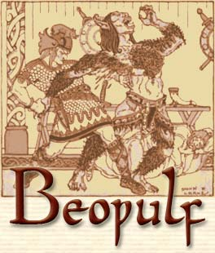
Beowulf is an Old English epic poem, which consists of 3,182 long lines. It is considered to be one of the most important books in Anglo-Saxon literature.
The poem is set in Scandinavia, although it was written in England. It uses different dialects of Old English for the spelling and has many different linguistic styles.
The lines in Beowulf use a lot of alliteration, meaning that they repeat certain syllables or sounds. Other well known poems and stories use this technique, including Sir Gawain and the Green Knight.
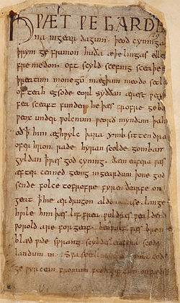
It is about a Scandinavian hero who defeats various monsters – the most famous of which are Grendel and Grendel’s mother – for the King of the Danes. The last part of the poem describes the hero Beowulf’s funeral.
Although the book is about a legend, the characters were probably based on real people. In parts of Scandinavia, archaeological discoveries suggest some elements of the story may be true.
It is not known with certainty who wrote Beowulf, although it is thought to have been put together sometime between the 8th and 11th centuries. It may have been written on behalf of King Canute (or Cnut), an 11th century Danish king.
Several people owned the Beowulf manuscript during the 16th and 17th centuries. Magna Carta as One of these people, Robert Cotton, also owned 2 copies of the well as the valuable Lindisfarne Gospels.
The only known existing copy of Beowulf is now in the British Library in London. The manuscript was put in paper frames to protect it, in 1845, although it is still very fragile.
Michael Morpurgo published a really successful children’s version of Beowulf.
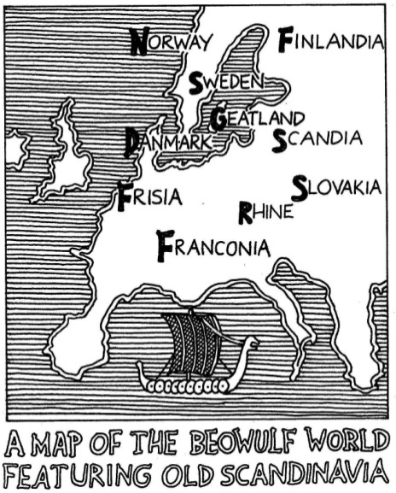
Beowulf has also been translated into many languages, including Greek, German, Japanese and Russian.
Beowulf has been featured in many novels, films and even computer games. There have also been several operas about the book, including at least one rock opera.

