“Beowulf” is the oldest story written in English. It is over 1000 years old. Nobody knows who the author (the person who wrote the story) was.
Beowulf was a great warrior. This is him shielding himself against a Dragon’s fire.
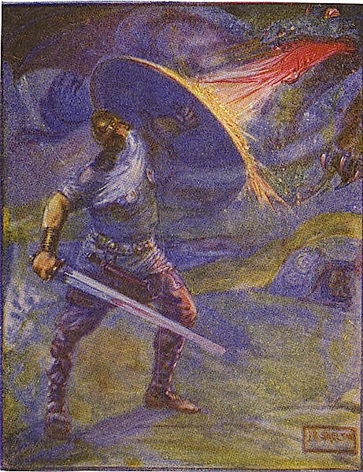

Grendel was the name of a monster that terrorized the Kingdom of the Geats (a very old tribe of people in England). Nobody knows what Grendel looked like, but he was supposed to be terrible to look at. Anyone who saw him had to look away. The author did not describe Grendel’s appearance so the reader could use their imagination. The only thing the author said about his appearance was that Grendel was awful to look at.
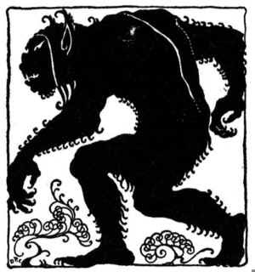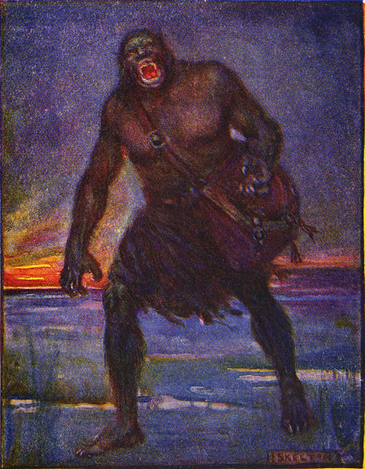

Ancient England was a dark, cold, scary and mysterious place. The only respite (break) from the hardship of the dark forests in the Land of the Geats was their mead hall. The mead hall was a large hall warmed by an enormous (gigantic/very big) fireplace. All the Geats in King Hrothgar’s kingdom came to the mead hall to drink mead, sing songs, and tell stories.
But the noise from the joy of the mead hall sometimes awakened (woke up) a terrible monster named Grendel. Whenever Grendel heard the Geats in the mead hall, he would break into the hall and kill and eat everyone. Everyone in the Kingdom was afraid of Grendel, but nobody knew what he looked like because if you were ever unlucky enough to see him, it meant you would not live to tell anyone about it.
King Hrothgar was very troubled by Grendel destroying his mead hall, so he summoned (called) a great warrior from the north named Beowulf. Beowulf was the only person in the Kingdom who wasn’t afraid of Grendel. Every night when the Geats gathered in the mead hall, Beowulf waited patiently for Grendel to appear.
One night, Grendel broke into the mead hall again. This time the Geats were ready for him. Grendel and Beowulf battled each other, and Beowulf ripped off the monster’s arm. Defeated, Grendel crawled back into his cave under a lake where he died. From then on, the Geats were able to live more peacefully, and were very grateful to Beowulf for protecting them.
Give a definition for the following words:
Gather: _________
Patiently: _________
Mysterious: _________
- Being able to wait without becoming upset
- Hard to understand, being strange.
- Coming together; assembling together.
- Read the following sentence: “The only thing the author said about his appearance was that Grendel was awful to look at.” Who is the word “his” referring to (talking about) in this sentence?
- The author
- Grendel
- Beowulf
- How old is the story Beowulf?

- Tell me one important event from the story. An “event” is a thing that happens.

- Which is not true about the character Beowulf: ________
- He was a famous warrior
- He was a coward
- He defeated the monster Grendel.
- He didn’t originally live in the Land of the Geats
- What other monster stories do you know?

- Does Korea have any stories about scary creatures, like monsters or ghosts? Tell me what happens in one of them.

- Make up a story about an epic battle or a monster or an ancient tribe (society). Your story can be funny or scary or serious or silly or anything else you like. It is your story.

- Draw a picture of what you think Grendel looked like.

