We´ve painted some pallets with P.E. Teacher José. We´ve painted them with a lot of colours.
In the English class, we´ve watched some videos about plants, houses,…
In one of them, the students plant seeds in plastic bottles.
1st _ They put soil in the bottles.
2nd_They plant seeds.
3rd_They water them. Then they look after the plants. They grow tomatoes, lettuces, carrots,…
In Los Villares , we´re working in a School Garden Project . I think it´s very nice.
I have a lot of ideas about it. I think it´s good because it helps plants to grow.
I´ve done this picture about one of the videos:
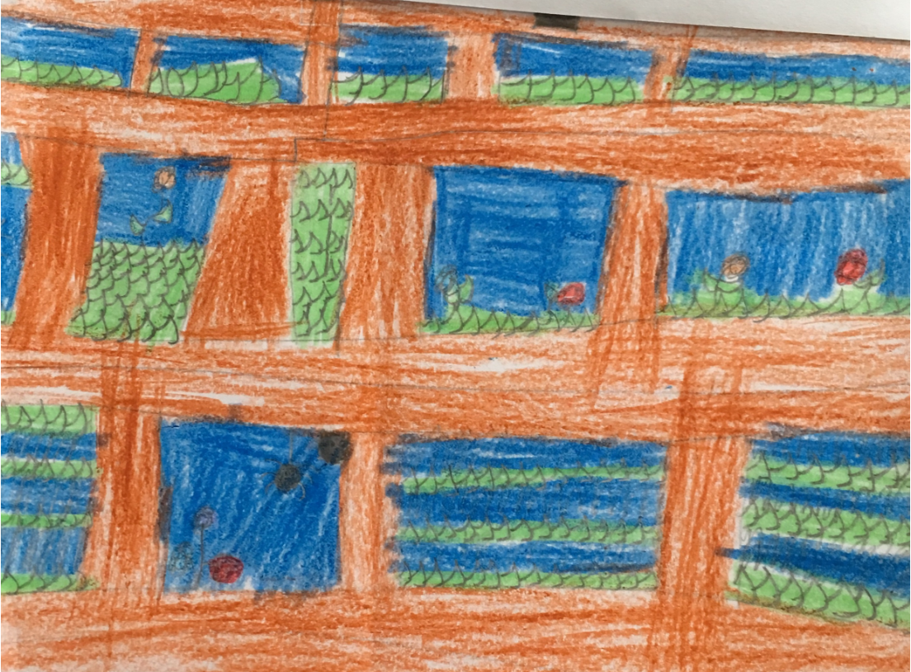
Pablo Barrilero Bascón. 3rd Course

