In my English class, we´ve watched two videos called:
-12 great pallet vertical gardens.
-The hanging garden project.
And with P.E. teacher José, we´ve sanded some pallets. We´ve painted them and we are going to plant many plants.
I like it very much.
I´ve done this picture about the 1st video.
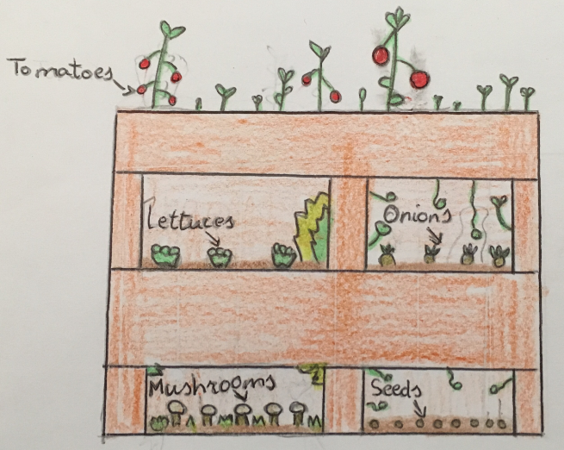
Paula Hidalgo Araque
3rd Course, Los Villares

