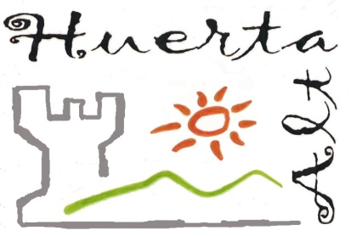
ENGLISH DEPARTMENT - IES HUERTA ALTA
Test Units 1 Block: Listening / level A
Listen to the recording and answer the questions according ONLY to it. Make sure you DON’T write in this piece of paper, your answer sheet is given separately. Use a PENCIL in you answer sheet. Remember that every wrong answer will be marked as -⅛ of a right answer.

Listen to the students talk about their projects in class.
- Which topic does Kieran talk about?
a. | wind farms | b. | solar-powered energy | c. | the greenhouse effect | d. | an eco-friendly company
- Which topic does Finley talk about?
a. | wind farms | b. | tents | c. | towers | d. | ships
- Which topic does Jess talk about?
a. | wind farms | b. | tents | c. | towers | d. | ships
- Using hot air as fuel is an idea being developed by a company from ____________.
a. | Spain | b. | Australia | c. | Austria | d. | France
- The idea has already been used in ___________.
a. | Germany | b. | Portugal | c. | Spain | d. | Australia
- The hot air fuel can generate enough electricity to power up to ____________ homes.
a. | 10,000 | b. | 200,000 | c. | 20,000 | d. | 100,000
- According to Finley, a lot of people __________ living near wind farms.
a. | hate | b. | like | c. | love | d. | can’t stand
- According to Finley, wind farms located in the ________ are the most powerful type of wind farms.
a. | seas | b. | mountains | c. | desert | d. | cities
- The idea that Jess talks about can help reduce the cost of __________.
a. | cargo ships | b. | fuel | c. | electricity | d. | coal
- Jess talks about an eco-friendly form of transporting _________
a. | people | b. | products | c. | clothing | d. | animals

KEY
1 | b
2 | a
3 | d
4 | b
5 | c
6 | d
7 | a
8 | a
9 | b
10 | b

