11 Best Vegetarian Salad Recipes | Easy Vegetarian Salad Recipes
Kriti Malik, NDTV | Updated: February 07, 2019 16:12 IST
Tweeterfacebook Reddit
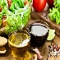
Highlights
- Eating a salad with colorful vegetables provides several unique nutrients
- Easy-to-prepare salads can help you feel cool in the soaring temperature
- Here are our top picks of vegetable salads which aren't boring at all
Best Vegetarian Salad Recipes: Once upon a time, vegetarian salads were described as just lettuce and tomatoes, with some commenting 'who orders that?' But thanks to a few chefs and other food enthusiasts, vegetarian salads started to probe both our appetite and imagination, with veggies going from being a supporting act to the main event. Ricotta, mushrooms, feta, sun-dried tomatoes, bell peppers, parsley, tarragon and garlic - these ingredients can be used to make a number of stellar dishes. You can also dress them up real nice. Yogurt-based dressings, balsamic vinegar, cold-pressed oils, cherry vinegar, herbs and warm spices: you can literally pick anything under the sun.
Before we get to some of the smashing vegetarian salad recipes we were talking about, we've got a few exciting tips for you that'll help you build an all-rounder salad that's not just a 10 on 10 in terms of taste, but brimming with all kinds of essential nutrients and minerals.

1. Go Green - Build a strong foundation before you get to the finer details. So pick lettuce, beans, broccoli and other greens as they'll fare as the most important and healthiest part of your salad. Why go green? Because green foods are a great source of phytonutrients. They help you regulate blood sugar during the day and are packed with fiber and water.

2. Time for Fiber - Lentils and legumes, flax seeds, chia seeds and hemp seeds are all rich in fiber and work well in salads. High fiber foods take longer to digest so they keep you full for longer. Fiber also helps with weight-loss and maintains smooth function of the gastric system.

3. Eat More Protein - You can get protein in your diet without having to chow down chicken or fish. Quinoa, buckwheat, soy/tofu, cottage cheese: these are all some great options that go well in a salad and in fact compliment all the other seasonal produce you plan to use. Protein helps reduce the risk of cardiovascular diseases and lowers blood pressure.

4. A Handful of Nuts - Nuts lend a great texture to salads. Try almonds, walnuts, pistachio, pine nuts and pecans: all of them work well. Nuts are also a powerhouse of energy, full of natural fibre, proteins, minerals and even unsaturated fats.

5. What's in Season? Pick the best of what's in season for it will be fresh and flavourful. It'll also be lighter on your budget. This means that pick up bright bell peppers, pumpkins, zucchini, mangoes, melons in the summers and cauliflower, peas and the like in the winter.

Now that you've got all you need to make yourself a warm and hearty vegetarian salad, let's move on to 10 genius recipes.

Here are 11 Best Vegetarian Salad Recipes You Must Try:

1. Carrot Salad with Black Grape Dressing
Carrots, almonds, raisins and spring onions work together to create a gorgeous desserts that's not only light on the stomach but also really refreshing. This healthy recipe has it all that takes to fight those extra pounds.

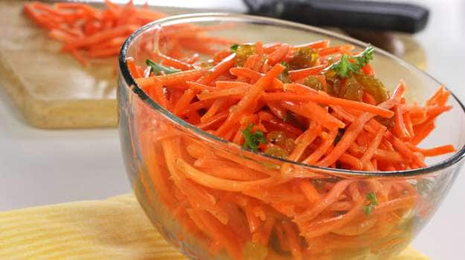Vegetarian salad recipes: Carrot Salad with Black Grape Dressing

2. Barley Salad
Toss up some red and yellow bell pepper, sun-kissed corn, cooked barley, garlic, parsley and a handful of other herbs for a salad so bright and healthy, it'll make you want more.Barley is a good source of soluble and insoluble fibre, vitamins, essential minerals (calcium, iron, manganese, magnesium, zinc and copper), anti-oxidants and phytochemicals which are believed to lower the risk of heart disease and diabetes

(Also Read: 5 Amazing Barley Water Benefits: Drink Up This Elixir to Good Health)
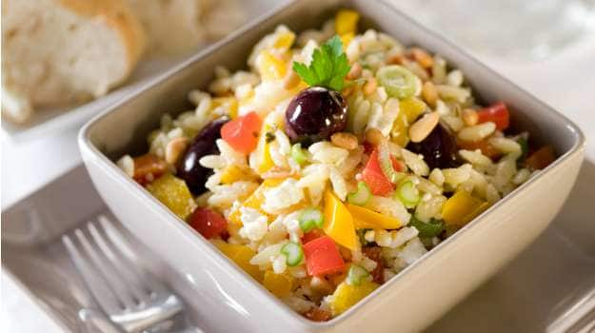Vegetarian salad recipes:Barley Salad

3. Green Bean Salad
A simple and quick salad that'll only take you only 15 minutes and 5 ingredients. Garlic, green beans, pepper, salt and olive oil. Green beans are rich in vitamins A, C, and K, they are a good source of folic acid and heart protective calcium and fiber. You Can leave out the eggs from the recipe.
(Also Read: Go Green! 7 Incredible Health Benefits of Green Beans)
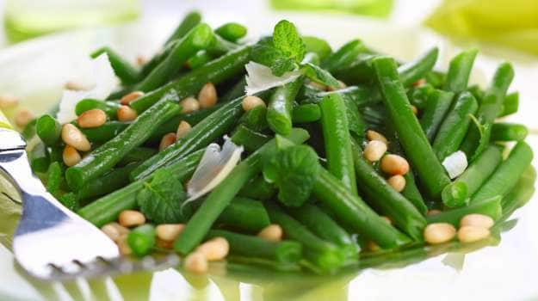

Vegetarian salad recipes: Green Bean Salad is a simple and quick salad that'll only take you only 15 minutes

4. Green Apple Salad
A Thai-inspired salad that's made with everything green, olive oil, salt and pepper. Healthy, refreshing and ever-so delightful, this recipe should be up on every fitness enthusiast's diet chart.
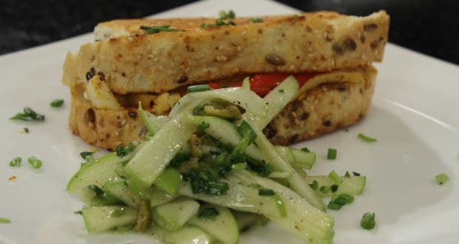
Green Apple Salad is a Thai inspired salad made with everything green and healthy.

5. Leafy Salad with Walnuts
A salad with different textures, nuts, vinegar, cherry tomatoes, crunchy lettuce and Chinese cabbage.Leafy greens are a good source of fibre and essential antioxidants. Fibre makes you feel full and keep cravings at bay.
(Also Read: 10 Best Pasta Salad Recipes​)
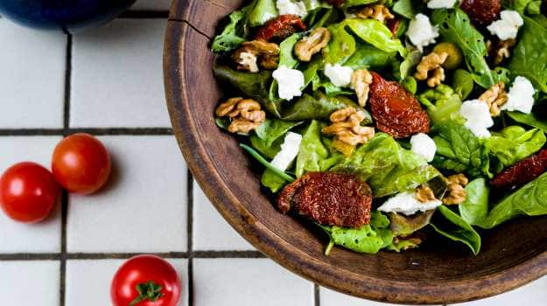
Vegetarian salad recipes: Leafy Salad with Vegetables

6. Pickled Beetroot with Feta
A really creative salad made with a reduction of wine, vinegar and sugar. The only other things you need are beetroot, feta cheese, pepper, green olives, cilantro and just a pinch of salt.

(Also Read: 11 Most Cooked Beetroot Recipes | Popular Beetroot Recipes)
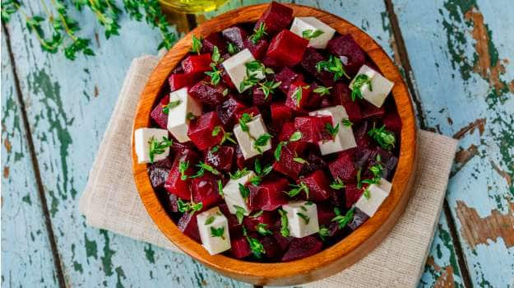Vegetarian salad recipes: Pickled Beetroot with Feta

7. Chipotle and Walnut Wheat Berry Salad
Carrots, thyme, walnuts, wine vinegar, raisins and a few more ingredients give you a salad that's slightly sweet, crunchy and a winner of a dish.
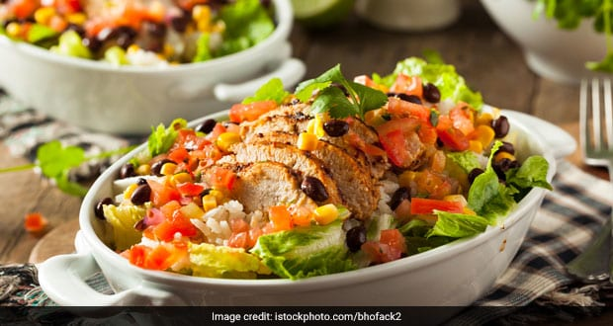Vegetarian salad recipes: Chipotle and Walnut Wheat Berry Salad

8. Crunchy Ribbon Salad
A whole lot of green, carrots and cucumber shredded real fine, cherry tomatoes and a mix of black and green olives.
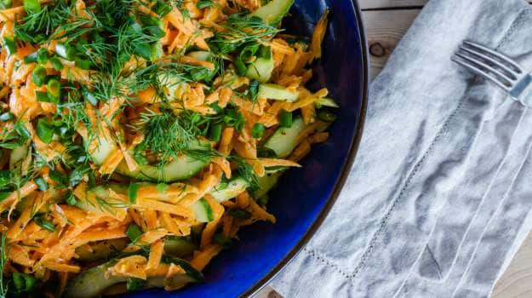Vegetarian salad recipes: Crunchy ribbon salad is made with whole lot of greens and veggies

9. Mediterranean Watermelon Salad
A refreshing salad that needs only around 20 minutes. Watermelon cubes, cucumbers, onions, pomegranate juice, mustard paste and a few more basic ingredients you'll find stocked somewhere in your kitchen cabinets.
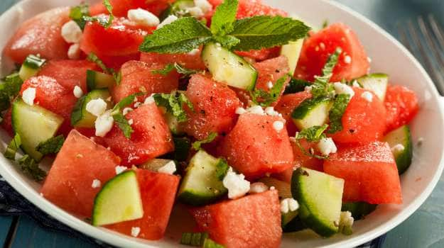Vegetarian salad recipes: Mediterranean Watermelon Salad
Comments

10. Quinoa Lentil Salad
Made with the goodness of Quinoa, asparagus, lentils, pomegranate, some tangy mustard dressing and mosambi juice. This one's a real power-booster. Quinoa is rich in protein, is cholesterol-free, gluten-free and a low GI food. It is an excellent source of various important phytochemicals and Vitamin E. It is rich in healthy fats too.
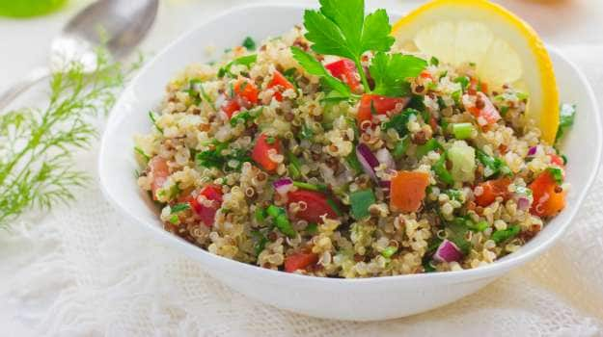
Vegetarian salad recipes: Quinoa Lentil Salad

11. Mixed Bean Salad
Rich with weight loss-friendly protein and fibres, this fresh spin on salad is sure to impress. This salad is made with the goodness of dried beans, capsicum and tomatoes dressed in sweet and sour flavours, and is perfect for days you want keep it light.
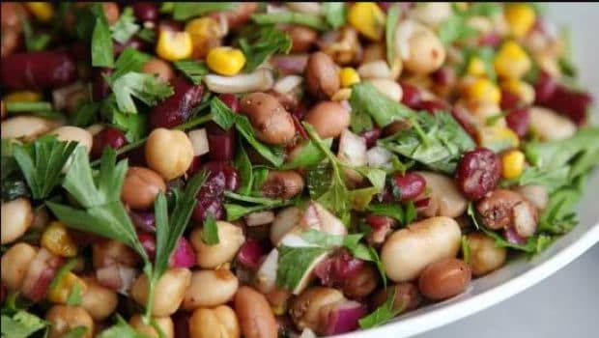
Vegetarian salad recipes: mixed bean salad
Salads are a great option for those looking to switch to healthy eating. According to Wayne Campbell, Professor of Nutrition Science at Purdue University in the United States, "Eating a salad with a variety of colorful vegetables provides several unique types of carotenoids, including beta-carotene, lutein, zeaxanthin and lycopene." So go and try all these salads at home and switch to healthy eating in an instant.

