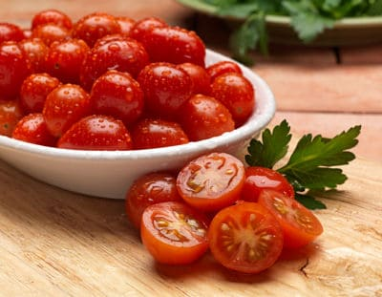
Cherry Tomatoes
Cherry tomatoes are a smaller variety of the garden tomatoes, which are comparatively sweeter than the larger fruits. They are relatively found in size of a thumb tip to the size of a golfball. These varieties of tomatoes are even juicier and hold many valuable nutrients.
These tiny tomatoes are less acidic and carry a milder flavor. They are easily grown in home gardens. Though the commonly found cherry tomatoes are red and green, there are varieties in white and black as well. These little bursts of flavor are adaptable to a wide range of meals. They are known to add instant flavor and colour to the meals. Cherry tomatoes are often used a garnish for their delightful appearance.
Cherry tomatoes are picked up when green and pickled into preparing a condiment called a tomolive. This pickled food is an excellent substitute for olive in a martini.
Nutritional value
1. Cherry tomatoes contain a high amount dietary fiber and potassium.
2. However, it cannot be consumed as regular food item for its high sugar levels.
3. Cherry tomatoes contain antioxidants that reduce the risk of cellular damage.
Did you know?
Cherry tomatoes have more Vitamin C content than garden tomatoes.
Cherry tomatoes have been under cultivation since 1800s

