

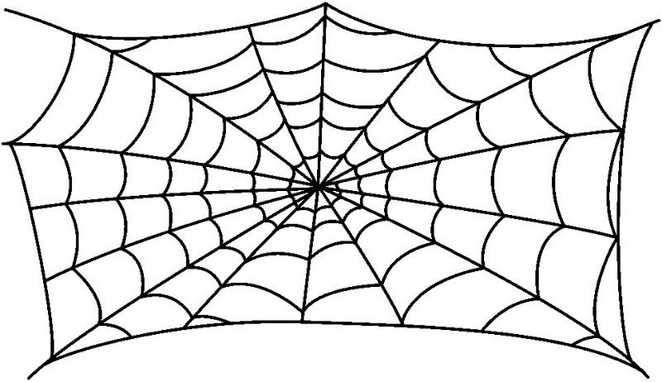

[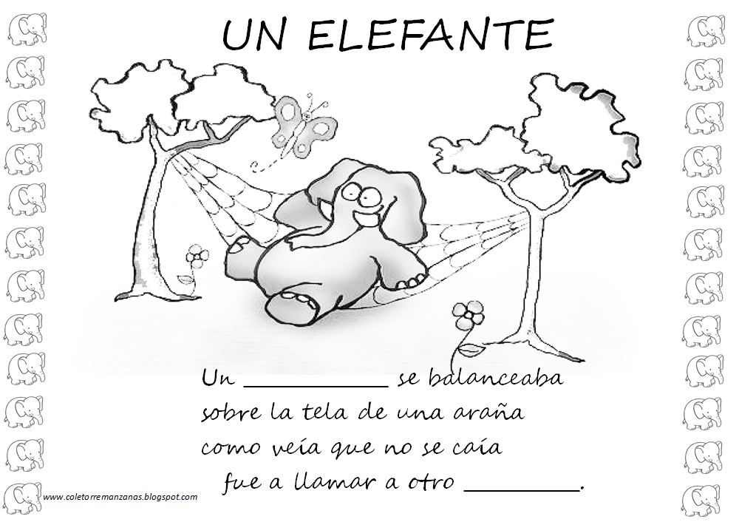](http://www.google.es/url?sa=i&rct=j&q=&esrc=s&frm=1&source=images&cd=&cad=rja&uact=8&ved=0ahUKEwjsyb3s2vzUAhWDIlAKHcYLDzAQjRwIBw&url=http%3A%2F%2Fwww.tocapartituras.com%2F2012%2F05%2Fpartituras-de-un-elefante-se-balanceaba.html&psig=AFQjCNHSnjfCPnOi6dzM2vMEs9XYs7L8jg&ust=1499707087317152)