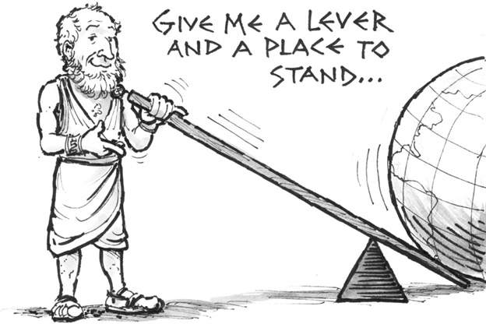
Archimedes
Archimedes is considered one of the greatest ___________ (1) of all time. He is also famed for his _______ (2) and for the colorful—though unproven—ways he is believed to have made them.
Little is known about Archimedes's life. He probably was born in the ______ (3) of Syracuse, a Greek settlement on the island of Sicily in the Mediterranean Sea. He was the son of an ________ (4) (someone who studies outer space, such as the stars) named Phidias. He may also have been related to Hieron, King of Syracuse, and his son Gelon.
Archimedes ______ (5) in the learning capital of Alexandria, Egypt, at the school that had been established by the Greek mathematician Euclid. He later returned to live in his native city of Syracuse.
There are many stories about how Archimedes made his __________ (6). A famous one tells how he uncovered an attempt to cheat King Hieron. The king ordered a golden ______ (7) and gave the crown's maker the exact amount of gold needed. The maker delivered a crown of the required weight, but Hieron suspected that some silver had been used instead of gold. He asked Archimedes to _______ (8) about the matter. One day Archimedes was considering it while he was getting into a _______ (9). He noticed that the amount of water _________ (10) the tub was _________ (11) to the amount of his body that was being immersed. This gave him an idea for solving the problem of the crown. He was so thrilled that he ran ______ (12) through the streets shouting, "Eureka!" (Greek for "I have discovered it!"). .
There are _________ (13) Archimedes may have determined the amount of silver in the crown. One likely method relies on an idea that is now called Archimedes's principle. It states that a body immersed in a fluid is _________ (14) by a force that is _________ (15) to the weight of fluid that is displaced by the body. Using this method, he would have first taken two equal weights of gold and silver and _________ (16) their weights when immersed in water. Next he would have compared the weight of the crown and an equal weight of pure silver in water in the same way. The difference ________ (17) these two comparisons would indicate that the crown was not pure gold.
Archimedes also studied aspects of the _______ (18) and _______ (19). A lever is a kind of basic machine in which a bar is used to raise or move a weight, while a pulley uses a ______ (20) and a ______(21) to lift loads.
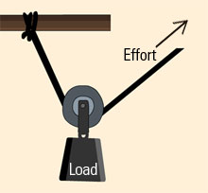
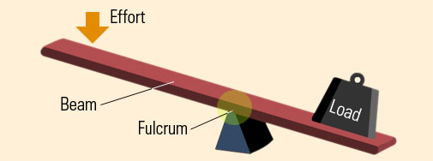

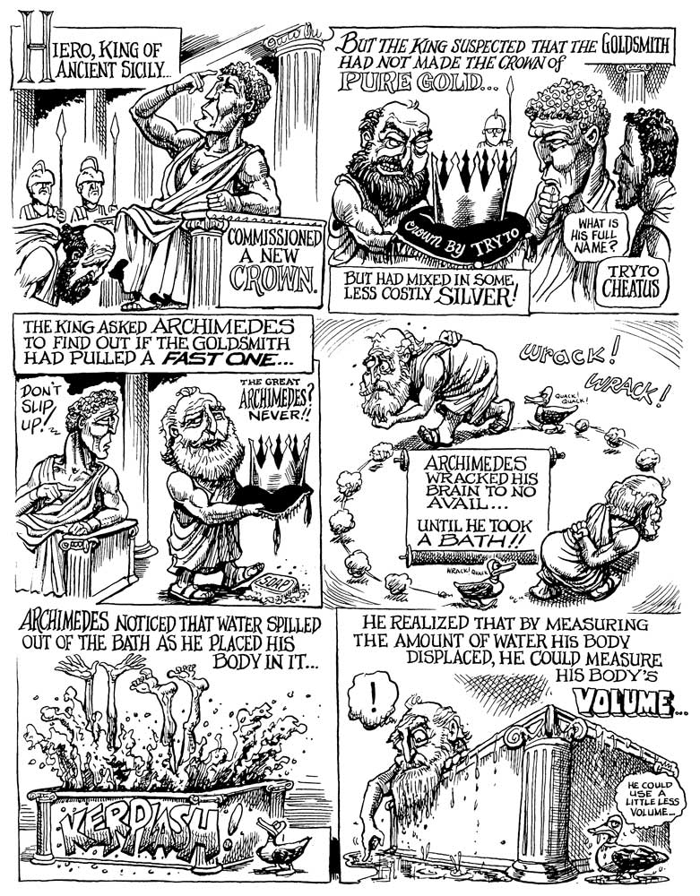

- Mathematicians
- inventions
- seaport city
- astronomer
- studied
- discoveries
- crown
- think
- bathtub
- overflowing
- proportional
- naked
- several ways
- pushed up
- equal
- compared
- between
- lever
- pulley
- wheel
- rope

