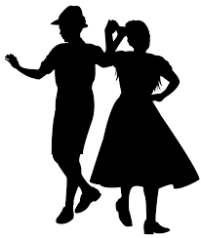
UNIT 11. BODY EXPRESSION
What is Body Language?
Body language is a non-verbal form of communication which is expressed through gestures, posture and other movements. We can express our desires, feelings, thougts, emotions and sensations by using it.
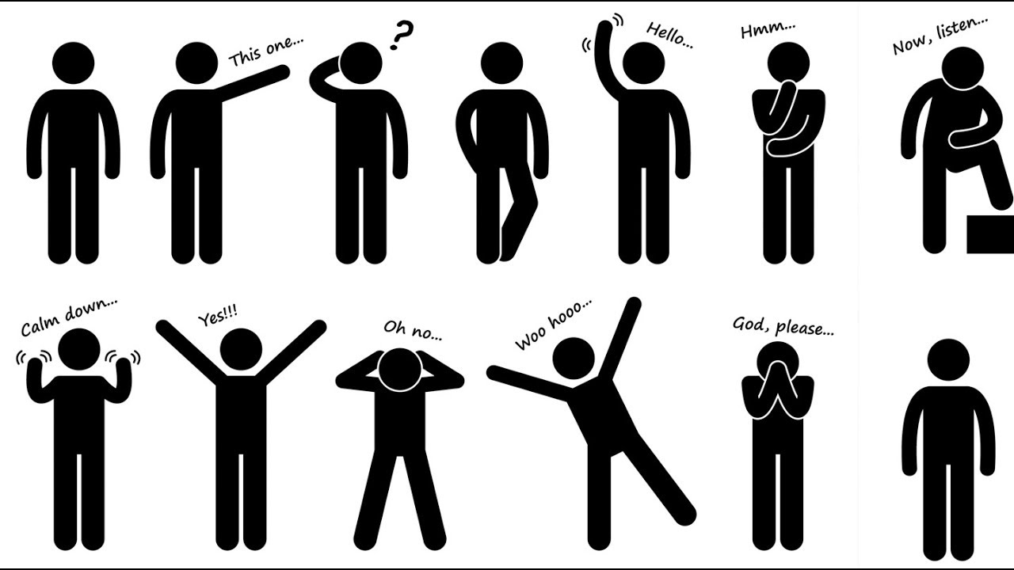

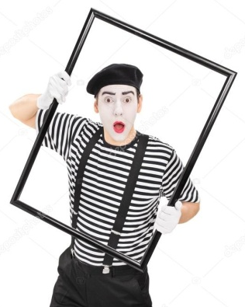
Why is it important?
We can receive the messages that the others are transmitting to us so we need to understand body language.

Examples: dramatic expression, rhythmic expression, dance, traditional dance.

TASK 1. Search on the internet three traditional dances and give a short explanation.
TASK 2. What must we do to communicate well in a non-verbal way with others?
TASK 3. How do you feel when you dance? Why?

