TASK (UNIT 4): INDOOR FOOTBALL I

- OBJECTIVE:
To earn points (score goals) by putting the ball in the opposite team's goal without using hands or arms.

- CHARACTERISTICS:

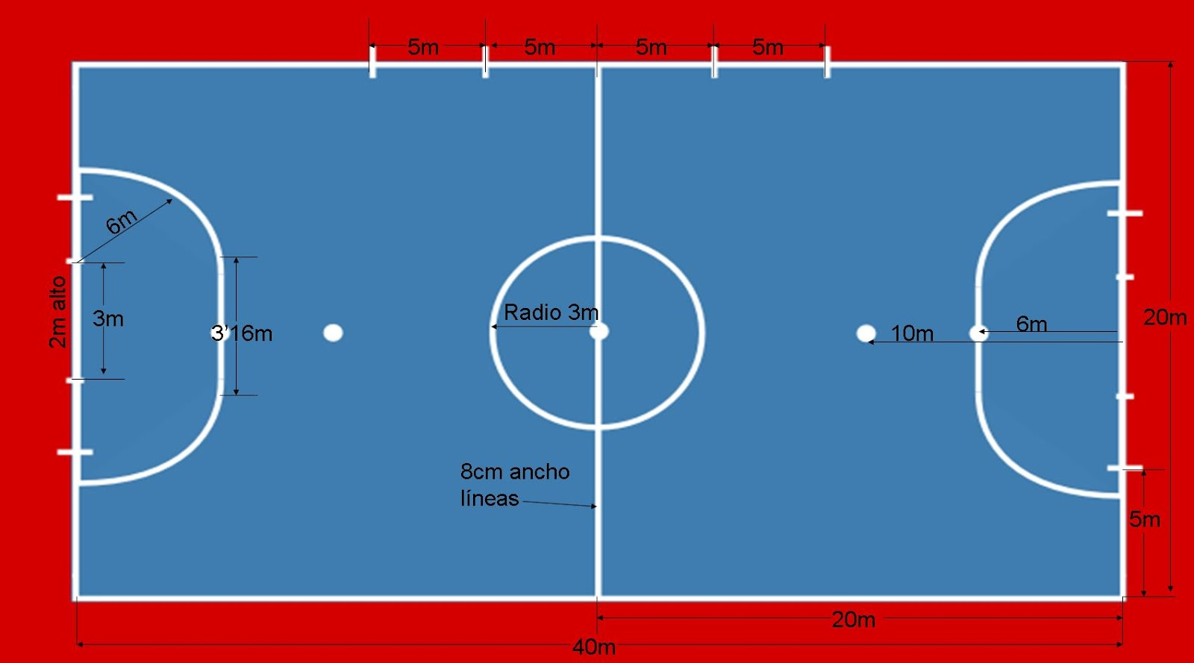

- ACTIVITY: What are the differences between indoor football and football?

