UNIT 4: INDOOR FOOTBALL II
1. Complete this indoor football pitch (rectangles).
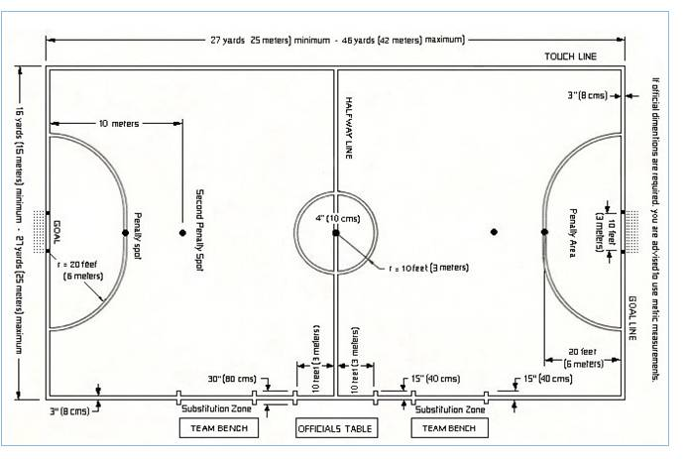
2. Write five principal/basic rules of indoor football.

3. What is the meaning of...? Describe the following words in English.
- Pivot or Striker:
- Midfielder or Winger:
- Last man/woman or Fixo:

