UNIT 5: ATHLETIC OLYMPIC GAMES II

TASK 1: Draw an athletic field and complete the following gaps:

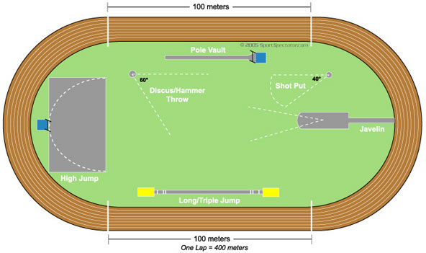

TASK 2: Do you know some Spanish athletes? Write ten lines about a woman and a man.

