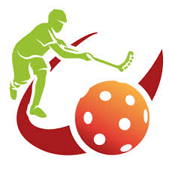
UNIT 6: FLOORBALL II
TASK 1. PLAYING AREA. Draw a floorball rink and colour the following zones: goal (black), restricted area or goal crease (yellow), centre spot (red), halfway line (orange)
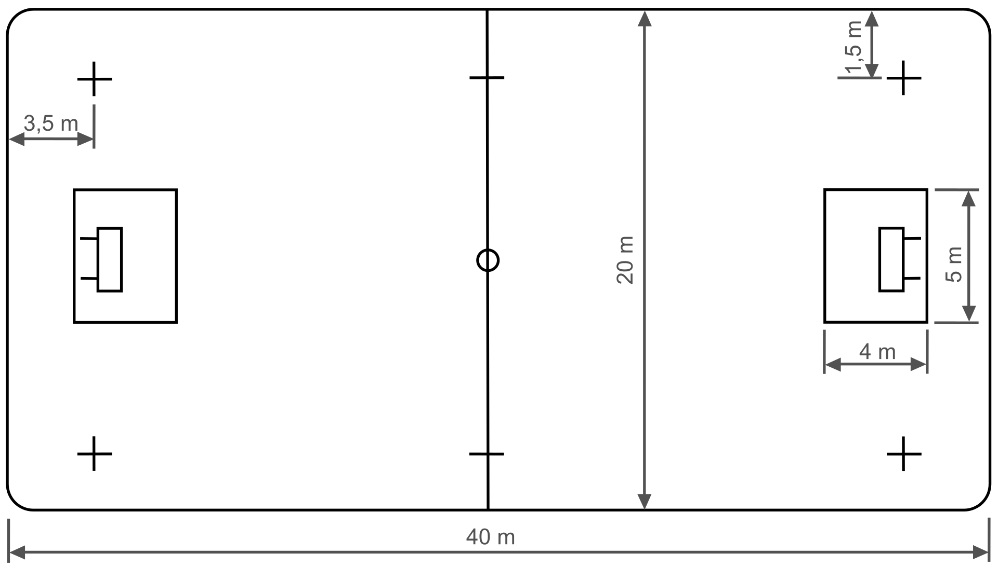
TASK 2. GLOSARY. Translate these words and complete the following sentences:

- Free-hit (2):
- Time-out:
- Referee:
- Uniform:
- Penalty choot-out:
- Fault:
- Raise:
- Grab:

All field players wear ................... consisting of jerseys, shorts and knee socks
When you commit a ..........., an opponent makes a ..............
During a .............., the opponent must be at least 3 meters away from the ball (sticks included).
Every match will be led and controlled by two equally authorized ...........................
A ....................... is the action of shooting a ball directly to the opponent goal without a goalkeeper.

During regular game time, each team shall have the right to request one ...................

Push or ............... other players is a forbidden action.
You can´t ............. the stick over the knee level but you can stop the ball with your feet.

