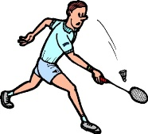
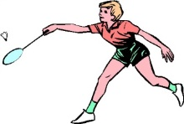
UNIT 7: BADMINTON I

- WHAT IS IT?
It is a racket sport played by either two opposing players (singles) or two opposing pairs (doubles). Badminton has been an Olympic sport since 1992 (Barcelona).

- CHARACTERISTICS:

TASK 1: Write five basic badminton rules.

TASK 2: Do you know some racket sports? (for example: tennis, padel, squash, beach tennis…). Describe one of them (what is it and characteristics).

