SOUP OF LETTERS – LAND RELIEF

SUBJECT | Geology
Description | Find the words
Sessions | 1
U.D. | 7
Content | Land relief
Assessment criteria
Orden 14 julio 2016
Key competences | Linguistic

ENGLISH CONTENT
Skills | Reading | Speaking | Listening | Writing | Cultural
 | X |  |  |  | X
Grammar

Vocabulary

ASSESSMENT
1 | 2 | 3 | 4 | 5 | 6 | 7 | 8 | 9 | 10 | TOTAL

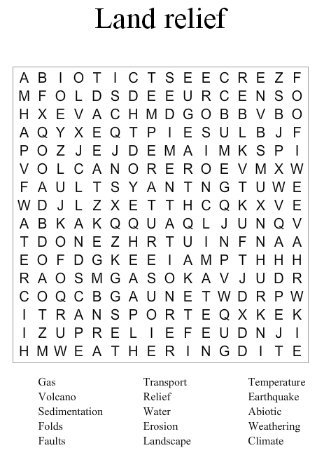
3º ESO. Biology- Geology
Prof. Dña Elena Castro Arcas
Elaborada en Educima.com

