What’s Prehistory?
SUBJECT | Geography and History
Description | Worksheet about the different periods in which Prehistory is divided and the reasons why.  The final task consist of drawing a timeline of the Prehistory.
Sessions | 2
U.D. | 7. La Prehistoria: el Paleolítico
Content | La periodización de la Prehistoria
Assessment criteria  Orden 14 julio 2016 | Bloque Historia: 3, 4, 5, 6
Key competences | CSC, CCL, CAA, CMCT

ENGLISH CONTENT
Skills | Reading | Speaking | Listening | Writing | Cultural
 | x | x | x | x
Grammar | - Past simple - At first, then, finally  - Which  - Called...  - Made of...
Vocabulary | - Writing system -Stone tools -Several - Hunting -Animal husbandry  - Settlement - To melt - Ornament - Weapon - Copper - Iron

ASSESSMENT
Participación e implicación |  |  |  | Buen uso de la lengua |  |  | Trabajo  Línea del tiempo
1 | 2 | 3 | 4 | 5 | 6 | 7 | 8 | 9 | 10 | TOTAL

PREHISTORY
Prehistory is the period of human life before the invention of the first writing systems (3500 BC). This period began when the first humans started to use stone tools (2.5 million years ago).
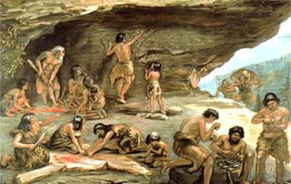
Prehistory is divided into several ages according to technologic evolution of the tools found. The first age is called the Stone Age, because during this period, humans used tools made of this material.
The Stone Age is divided into two different periods:
- Palaeolithic, which means “old stone”. It started 2.5 million years ago (when Homo habilis started to elaborate tools). It is divided into three ages: Lower Palaeolithic, Middle Palaeolithic and Upper Palaeolithic. It is followed by a transition age called Mesolithic. Palaeolithic people were nomads, they moved from one place to another hunting animals, fishing and gathering fruits and seeds.

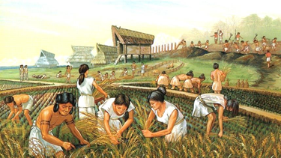
- Neolithic, which means “new stone”. It started around 8000 BC, when humans developed agriculture and animal husbandry. People who lived during the Neolithic learned how to produce food and established the first settlements.

The Stone Age is followed by the Metal Age. Humans learned how to melt metals and work them to make ornaments, tools and weapons. The Metal Age is also divided into three ages:
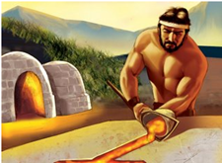
- At first, these objects were made of copper (around 4000 BC).
- Then, objects were made of bronze (around 3000 BC).
- Finally, humans learned how to melt and work iron (around 1500 BC).
During the Metal Age, society became more complex. Social differences began to appear, like being rich or poor.
The dates of the beginning and end of each age depend on certain technologic advances, this means that this periodization varies from one region of the world to other. For example, in the Iberian Peninsula, the Neolithic started in 6000 BC.

