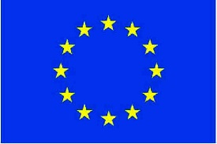

The European Union is a group of countries that have signed a treaty. This treaty is a promise to take part in the trading of goods and the free movement of people.
The main currency in the EU is the ‘Euro’ with 19 countries using it. However, 9 of the 28 countries do not trade using the Euro.

EU Country | Currency | Currency Symbol | Euro to the currency
Bulgaria | Bulgarian lev | Лв. | €0.51
Croatia | Croatian kuna | kn | €0.13
Czech Republic | Czech koruna | Kč | €0.039
Denmark | Danish krone | Kr. | €0.13
Hungary | Hungarian forint | Ft | €0.0031
Poland | Polish złoty | zł | €0.23
Romania | Romanian leu | lei | €0.21
Sweden | Swedish krona | kr | €0.093
United Kingdom | Pound | £ | €1.14

Questions
- 1 Kr. is equal to how many euros/cents?

- £6 is equal to how many euros/cents?

- 11 zł is equal to how many euros/cents?

- In Romania, a chocolate bar costs 50 lei, how much is this in euros?

- How many Czech koruna are there in 50€? Remember to round your answer.

- If I go on holiday to Bulgaria with 300€ to spend, how many Bulgarian lev will I have?

- I have 65 kn left from my trip to Croatia. If I change my money back to euros, how many euros will I have?

- In Hungary, I go to the supermarket and buy some fruit, vegetables, a fizzy drink, a tub of ice-cream, ham and some chicken. It costs €36.17. How many Hungarian forint do I need?

- A ticket to a museum in Sweden costs 5 kr. How many euros/cents will this be?

