PORTFOLIO

Passport

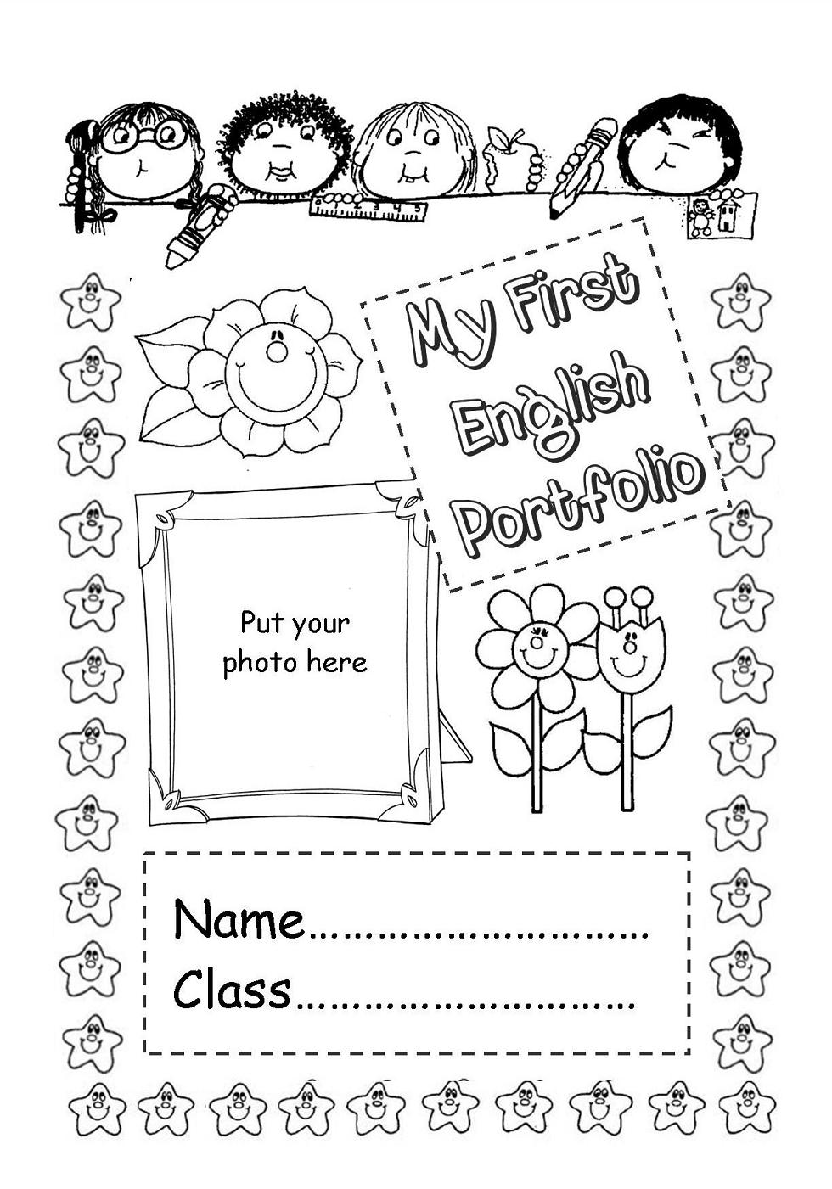

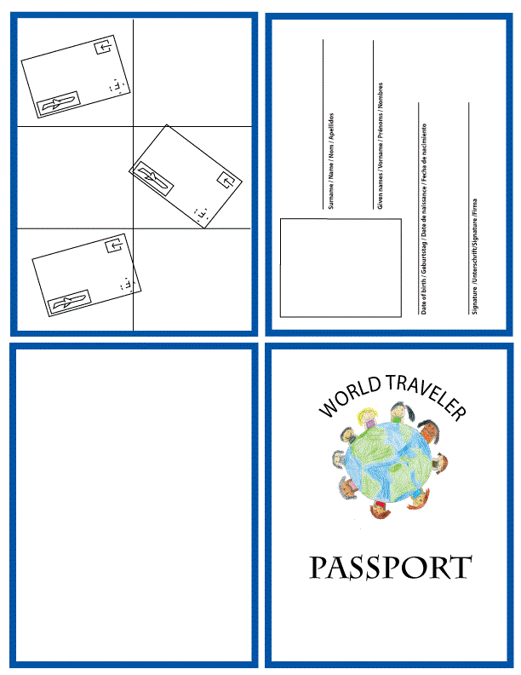

PORTFOLIO

Biography



**Biography:Languages**

|  |
| --- |
| 1. Mother tongue: …………………………………………..  None A1 A2 B1 B2 C1 C2 Native S. |
| I can…  https://cdn.dribbble.com/users/130631/screenshots/632138/550_teaser.png |

|  |
| --- |
| 2. In English…  None A1 A2 B1 B2 C1 C2 Native S. |
| I can…  https://cdn.dribbble.com/users/130631/screenshots/632138/550_teaser.png |

|  |
| --- |
| 3. Other languages: …………………………………..  None A1 A2 B1 B2 C1 C2 Native S. |
| I can…  https://cdn.dribbble.com/users/130631/screenshots/632138/550_teaser.png |

**Biography:My English experiences**

|  |  |
| --- | --- |
| **When?**Resultado de imagen de time icon | **What?** |
| Yesterday  The last year  A long time ago | I go to London |
| **Anecdotes** | |
| Do the grocery shopping | |
| **How was it? Circle** | **Where? Colour!** |
| **C:\Users\jeane\AppData\Local\Microsoft\Windows\INetCache\Content.Word\quadrantFaces.pngGood!**  **quadrantFaces - copiaSo,so…**  **Bad!** | Imagen relacionada |
| **Draw and colour it:**Resultado de imagen de drawing icon | |
| **When?** Resultado de imagen de time icon | **What?** |
| Yesterday  The last year  A long time ago |  |
| **Anecdotes** | |
|  | |
| **How was it?** | **Where? Colour!** |
| **C:\Users\jeane\AppData\Local\Microsoft\Windows\INetCache\Content.Word\quadrantFaces.pngGood!**  **quadrantFaces - copiaSo,so…**  **Bad!** | Imagen relacionada |
| **Draw and colour it:**Resultado de imagen de drawing icon | |

***Biography:* How can I learn English?**

|  |  |
| --- | --- |
| **When I…** | **I…** |
| Resultado de imagen de listen | Listen carefully. |
| Resultado de imagen de speak icon | Look and say.  Repeat  Say. |
| Conversation, Dialogue, Interview, Icon, Communication | Listen to my partner.  Answer and have fun. |
| Resultado de imagen de reading icon | Read carefully  Look up the words in the dictionary. |
| Resultado de imagen de write icon | Remember and copy in the worksheet. |

***Biography:* Unit 1: This is my body!**

|  |  |  |  |
| --- | --- | --- | --- |
| **I can already…** | **VERY WELL!**  **C:\Users\jeane\AppData\Local\Microsoft\Windows\INetCache\Content.Word\quadrantFaces.png** | **SO, SO…** | **NOT WELL** |
| Say “Hello” and“Good morning”.  Imagen relacionada |  |  |  |
| Say parts of the body. |  |  |  |
| Say ‘Goodbye’ or ‘Bye-bye’. |  |  |  |

**By the end of the unit 1…**

|  |  |  |  |  |
| --- | --- | --- | --- | --- |
| **I will…** | **VERY WELL!**  **C:\Users\jeane\AppData\Local\Microsoft\Windows\INetCache\Content.Word\quadrantFaces.png** | | **SO, SO…**  **C:\Users\jeane\AppData\Local\Microsoft\Windows\INetCache\Content.Word\quadrantFaces - copia.png** | **NOT WELL** |
| Resultado de imagen de listen**Listen to…** | | | | |
| Parts of the body.  Resultado de imagen de music icon |  | |  |  |
| Greetings and parts of the body in stories.  Imagen relacionada |  | |  |  |
| Resultado de imagen de speak icon  **Speak to…** | | | | |
| other people about me.  Resultado de imagen de conversation icon | |  |  |  |
| Sing the song.  Resultado de imagen de music icon | |  |  |  |
| Conversation, Dialogue, Interview, Icon, Communication **Ask other people…** | | | | |
| Parts of the body.  Resultado de imagen de conversation icon | |  |  |  |
| Resultado de imagen de reading icon**Read…** | | | | |
| English greetings  Resultado de imagen de hello icon | |  |  |  |
| Questions and instructions  **?** | |  |  |  |
| Resultado de imagen de write icon**Write…** | | | | |
| A work-out planning  Resultado de imagen de work out icon | |  |  |  |

PORTFOLIO

Dossier

**Dossier:Index of my Works**

|  |  |  |
| --- | --- | --- |
| **TERM** | **TITLE AND TYPE** | **DESCRIPTION** |
| **1stunit** | **1.My work-out planning** | Activity to establish a work-out routine to identify some actions to keep fit. |
| **2.** |  |
| **3.** |  |
| **4.** |  |
| **2ndunit** | ***5.*** |  |
| ***6.*** |  |
| ***7.*** |  |
| ***8.*** |  |
| **3rdunit** | ***9.*** |  |
| ***10.*** |  |
| ***11.*** |  |
| ***12.*** |  |