Book title ______________________________________
Author ________________________________________
Genre ________________________________________
What do you think of the cover? _______________
_______________________________________________
_______________________________________________
Why have you chosen this book? ______________
_______________________________________________
_______________________________________________
Would you read this book? _____________________
Why (not)? ____________________________________
_______________________________________________

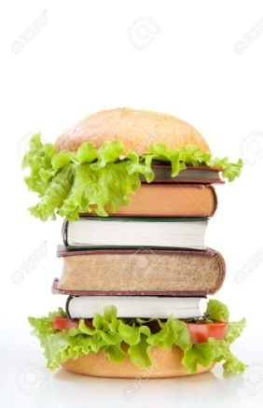
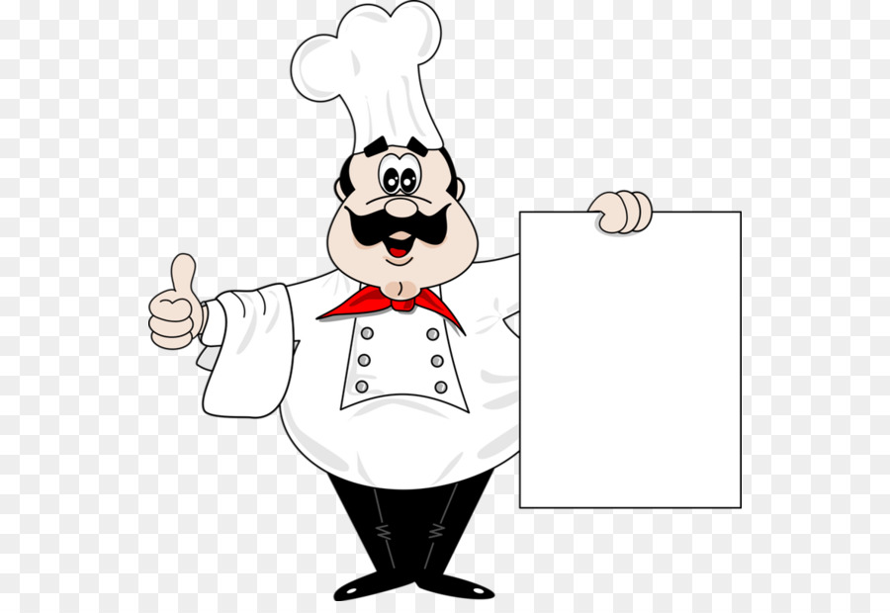
Book Tasting

