MY FAVOURITE PET  My favourite pet is a …………….  It is ……………………………………….  It has got ……………… legs.  It has got a ………………. tail.  It has got …………………. ears.  It is ……………………………………….  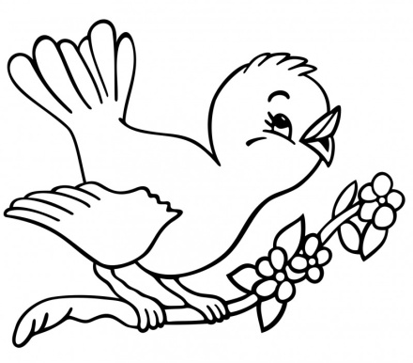 | MY FAVOURITE PET  My favourite pet is a …………….  It is ……………………………………….  It has got ……………… legs.  It has got a ………………. tail.  It has got …………………. ears.  It is ……………………………………….  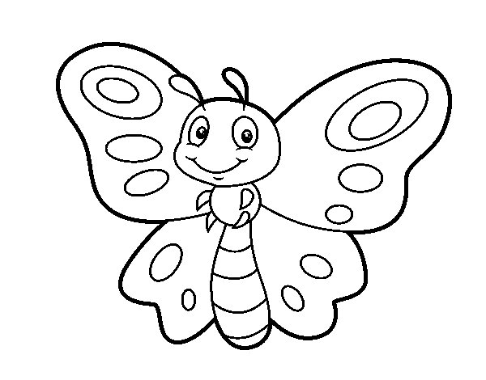
MY FAVOURITE PET  My favourite pet is a …………….  It is ……………………………………….  It has got ……………… legs.  It has got a ………………. tail.  It has got …………………. ears.  It is ……………………………………….  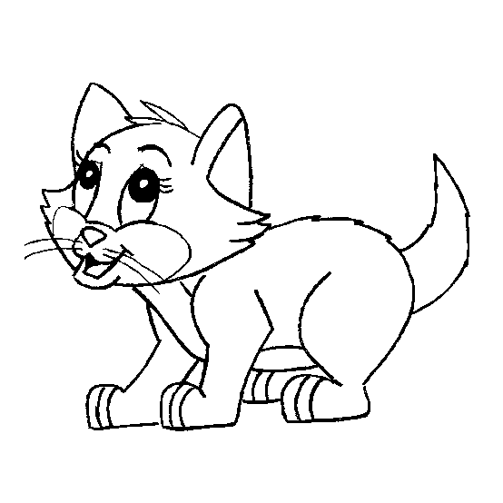 | MY FAVOURITE PET  My favourite pet is a …………….  It is ……………………………………….  It has got ……………… legs.  It has got a ………………. tail.  It has got …………………. ears.  It is ……………………………………….  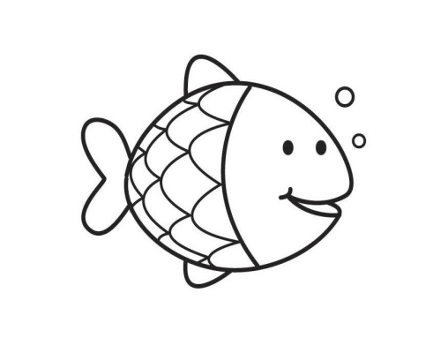

MY FAVOURITE PET  My favourite pet is a …………….  It is ……………………………………….  It has got ……………… legs.  It has got a ………………. tail.  It has got …………………. ears.  It is ……………………………………….  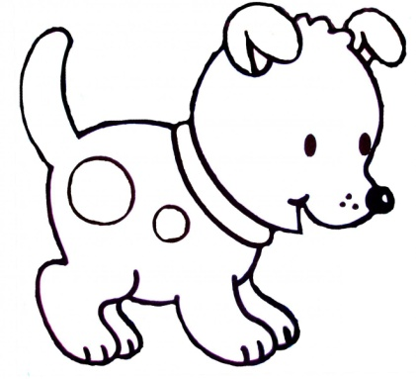 | MY FAVOURITE PET  My favourite pet is a …………….  It is ……………………………………….  It has got ……………… legs.  It has got a ………………. tail.  It has got …………………. ears.  It is ……………………………………….  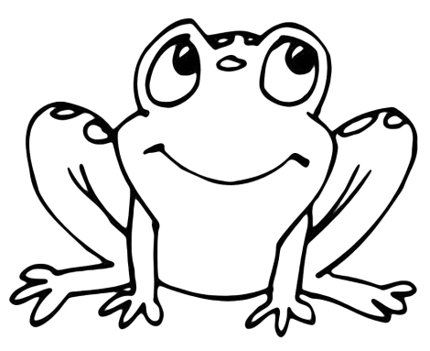
MY FAVOURITE PET  My favourite pet is a …………….  It is ……………………………………….  It has got ……………… legs.  It has got a ………………. tail.  It has got …………………. ears.  It is ……………………………………….  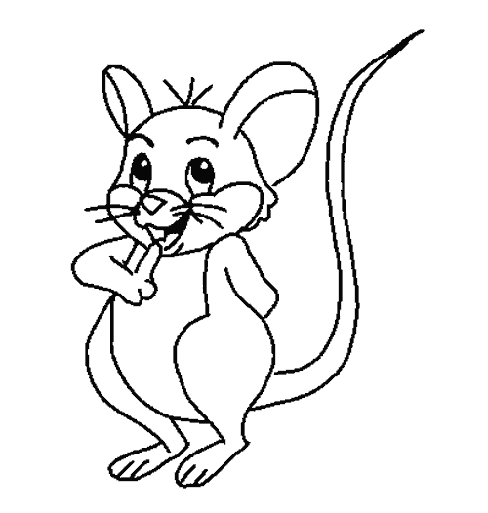 | MY FAVOURITE PET  My favourite pet is a …………….  It is ……………………………………….  It has got ……………… legs.  It has got a ………………. tail.  It has got …………………. ears.  It is ……………………………………….  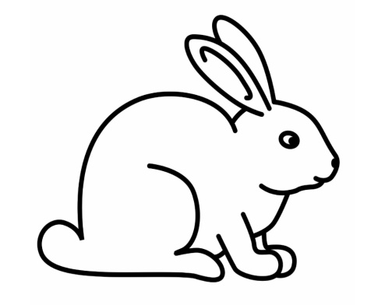

MY FAVOURITE PET  My favourite pet is a …………….  It is ……………………………………….  It has got ……………… legs.  It has got a ………………. tail.  It has got …………………. ears.  It is ………………………………………. | MY FAVOURITE PET  My favourite pet is a …………….  It is ……………………………………….  It has got ……………… legs.  It has got a ………………. tail.  It has got …………………. ears.  It is ……………………………………….
MY FAVOURITE PET  My favourite pet is a …………….  It is ……………………………………….  It has got ……………… legs.  It has got a ………………. tail.  It has got …………………. ears.  It is ………………………………………. | MY FAVOURITE PET  My favourite pet is a …………….  It is ……………………………………….  It has got ……………… legs.  It has got a ………………. tail.  It has got …………………. ears.  It is ……………………………………….

